金門縣山坡地範圍劃定計畫(草案)

提報機關：行政院農業委員會
中華民國 107 年11月

目錄
壹、劃定地點 1
貳、劃定原因 3
參、作業方式 4
肆、相關圖冊 7
一、鄉鎮山坡地範圍圖(通用電子地圖為底圖) 7
二、地段山坡地範圍圖(五千分之一基本圖為底圖) 10
伍、地段土地清冊 27
陸、附件光碟 47

圖目錄
圖1金門縣劃定山坡地範圍圖 2
圖2金門縣等高線圖 5
圖3金門縣數值高程模型圖 5
圖4金門縣高程分析圖 6
圖5金門縣坡度等級分析圖 6
圖6金門縣金城鎮山坡地範圍位置圖 8
圖7金門縣金湖鎮山坡地範圍位置圖 8
圖8金門縣金沙鎮山坡地範圍位置圖 9
圖9金門縣烈嶼鄉山坡地範圍位置圖 9
圖10金門縣山坡地範圍圖-金城鎮水頭段 11
圖11金門縣山坡地範圍圖-金城鎮珠山段 11
圖12金門縣山坡地範圍圖-金城鎮東紅山段 12
圖13金門縣山坡地範圍圖-金湖鎮小徑段 12
圖14金門縣山坡地範圍圖-金湖鎮夏興段 13
圖15金門縣山坡地範圍圖-金湖鎮塔后段 13
圖16金門縣山坡地範圍圖-金湖鎮太武段 14
圖17金門縣山坡地範圍圖-金湖鎮南雄段 14
圖18金門縣山坡地範圍圖-金湖鎮士校段 15
圖19金門縣山坡地範圍圖-金沙鎮山后段 15
圖20金門縣山坡地範圍圖-金沙鎮山柄段 16
圖21金門縣山坡地範圍圖-金沙鎮大山段 16
圖22金門縣山坡地範圍圖-金沙鎮擎天段 17
圖23金門縣山坡地範圍圖-金沙鎮山西段 17
圖24金門縣山坡地範圍圖-金沙鎮碧山段 18
圖25金門縣山坡地範圍圖-金沙鎮浯坑劃測段 18
圖26金門縣山坡地範圍圖-金沙鎮西園測段 19
圖27金門縣山坡地範圍圖-烈嶼鄉古廟段 19
圖28金門縣山坡地範圍圖-烈嶼鄉后宅段 20
圖29金門縣山坡地範圍圖-烈嶼鄉西方段 20
圖30金門縣山坡地範圍圖-烈嶼鄉大山頂測段 21
圖31金門縣山坡地範圍圖-烈嶼鄉楊厝測段 21
圖32金門縣山坡地範圍圖-烈嶼鄉福上山測段 22
圖33金門縣山坡地範圍圖-烈嶼鄉紅山測段 22
圖34金門縣山坡地範圍圖-烈嶼鄉公園測段 23
圖35金門縣山坡地範圍圖-烈嶼鄉龍骨山測段 23
圖36金門縣山坡地範圍圖-烈嶼鄉九宮測段 24
圖37金門縣山坡地範圍圖-烈嶼鄉東面山測段 24
圖38金門縣山坡地範圍圖-烈嶼鄉庵下測段 25
圖39金門縣山坡地範圍圖-烈嶼鄉大膽段 25
圖40金門縣山坡地範圍圖-烈嶼鄉二擔段 26

表目錄
表1金門縣山坡地範圍劃定分區面積統計 1
表2金門縣各鄉鎮劃定山坡地範圍地段統計 1
表3金門縣山坡地範圍劃定面積統計表 2

壹、劃定地點
金門縣山坡地範圍劃定之地區主要分布為金湖鎮與金沙鎮太武山、金沙鎮之獅山、五龍山、金龜山，金城鎮之梁山、塔山，烈嶼鄉之麒麟山、大山頂、上岐及等10區加上大膽島及二膽島，金門縣共劃定12個山坡地範圍分區，各分區面積統計如表1，分布於31個地籍地段，山坡地範圍各鄉鎮地段統計如表2，劃定後之山坡地範圍面積為1,806.40公頃如圖1。山坡地範圍劃定各地段面積統計如表3。
表1金門縣山坡地範圍劃定分區面積統計
範圍分區編號 | 山坡地面積(公頃)
金城-1 | 10.9
金城-2 | 69.77
金城-3 | 53.92
金湖-1 | 916.56
金沙-1 | 227.75
金沙-2 | 13.87
金沙-3 | 12.11
烈嶼-1 | 306.15
烈嶼-2 | 95.12
烈嶼-3 | 11.81
烈嶼-4 | 61.53
烈嶼-5 | 27.33
合計 | 1,806.40
表2金門縣各鄉鎮劃定山坡地範圍地段統計
鄉鎮 | 地段數
金城鎮 | 3
金湖鎮 | 6
金沙鎮 | 8
烈嶼鄉 | 14
總計 | 31
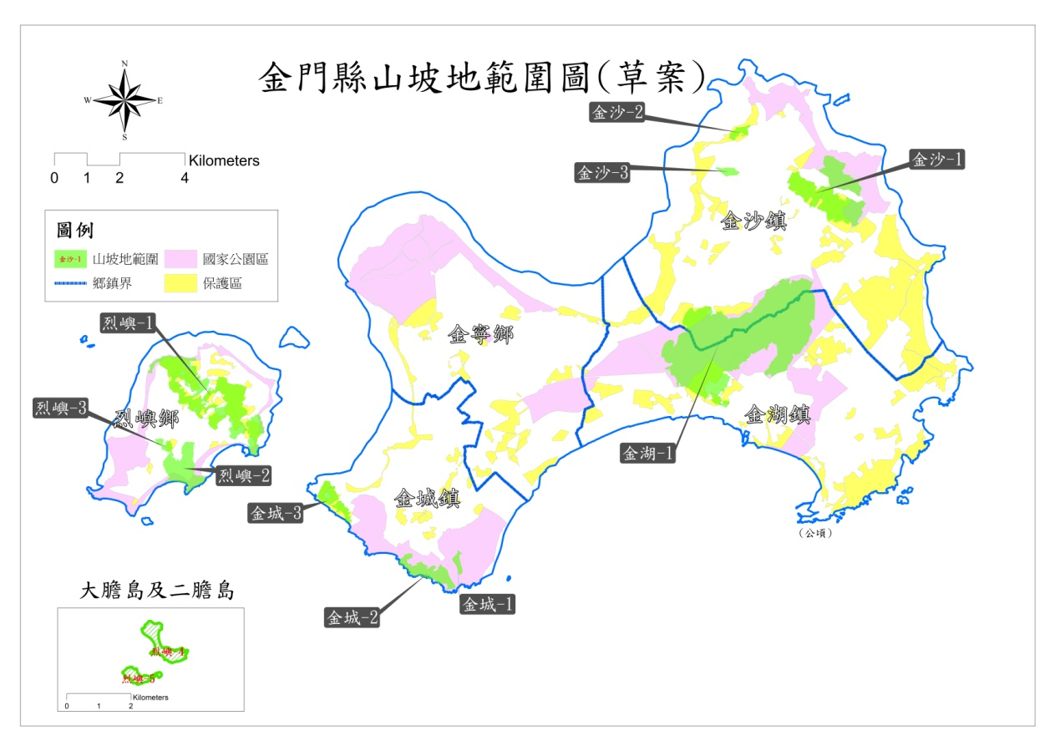
圖1金門縣劃定山坡地範圍圖
表3金門縣山坡地範圍劃定面積統計表
編號 | 鄉鎮 | 地段 | 土地筆數 | 山坡地面積  (公頃)
1 | 金城鎮 | 水頭 | 135 | 43.98
2 | 金城鎮 | 珠山 | 20 | 11.18
3 | 金城鎮 | 東紅山 | 880 | 63.23
4 | 金湖鎮 | 小徑 | 621 | 74.11
5 | 金湖鎮 | 夏興 | 1043 | 134.82
6 | 金湖鎮 | 塔后 | 238 | 30.27
7 | 金湖鎮 | 太武 | 144 | 134.25
8 | 金湖鎮 | 南雄 | 320 | 37.8
9 | 金湖鎮 | 士校 | 2 | 4.91
10 | 金沙鎮 | 山后 | 147 | 24.5
11 | 金沙鎮 | 山柄 | 677 | 67.42
12 | 金沙鎮 | 大山 | 154 | 333.89
13 | 金沙鎮 | 擎天 | 289 | 166.97
14 | 金沙鎮 | 山西 | 424 | 59.22
15 | 金沙鎮 | 碧山 | 370 | 75.99
16 | 金沙鎮 | 浯坑劃測 | 44 | 12.8
17 | 金沙鎮 | 西園測 | 160 | 13.15
18 | 烈嶼鄉 | 古廟 | 59 | 1.54
19 | 烈嶼鄉 | 后宅 | 81 | 1.54
20 | 烈嶼鄉 | 西方 | 59 | 3.32
21 | 烈嶼鄉 | 大山頂測 | 222 | 74.93
22 | 烈嶼鄉 | 楊厝測 | 72 | 20.12
23 | 烈嶼鄉 | 福上山測 | 56 | 11.78
24 | 烈嶼鄉 | 紅山測 | 459 | 56.88
25 | 烈嶼鄉 | 公園測 | 404 | 23.22
26 | 烈嶼鄉 | 龍骨山測 | 418 | 87.6
27 | 烈嶼鄉 | 九宮測 | 874 | 40.89
28 | 烈嶼鄉 | 東面山測 | 670 | 33.76
29 | 烈嶼鄉 | 庵下測 | 542 | 57.57
30 | 烈嶼鄉 | 大膽 | 60 | 61.41
31 | 烈嶼鄉 | 二擔 | 30 | 27.28
32 | 金城鎮 | (海岸無地籍) |  | 16.07
 | 合計 |  | 9,674 | 1806.40

貳、劃定原因
山坡地保育利用條例於民國65年4月29日公布實施後，臺灣省政府即依該條例第3條規定，著手進行山坡地範圍之劃定作業，當時係由台灣省政府農林廳山地農牧局（水土保持局前身）辦理台灣省山坡地範圍（不含福建省、台北市及高雄市轄區）之初劃工作，之後再邀集各縣市政府開會討論確定，並於68年11月21日經行政院核定，由臺灣省政府於69年2月6日公告在案。精省後，因修正水土保持法第3條第3款及山坡地保育利用條例第3條，而修正劃定單位為行政院農業委員會，核定單位仍為行政院。此外，因初劃時金門縣屬戰地，並未納入山坡地範圍劃定，以致迄今尚無水土保持法之適用，無法推動山坡地水土保持管理。
為落實金門縣之水土保持處理與維護及保育水土資源、涵養水源、減免災害、促進土地合理利用，本計畫辦理金門縣之山坡地範圍劃定工作。

參、作業方式
金門縣山坡地範圍境界線之劃定，須依數值地形模型及像片基本圖進行坡度（5％為界線）及高程（100公尺為界線）之分析，並參考地籍圖，依自然環境、地籍完整性等項目劃定金門縣之山坡地範圍境界線。
一、劃定原則
(一)山坡地境界線劃設除依水土保持法規定標高在100公尺以上，標高未滿100公尺，而其平均坡度在5％以上外，應儘量依坡度、地籍、國家公園區與保護區及開發利用情形等，綜合判斷，並考量金門花崗岩特殊地質及土壤沖蝕情形相對輕微，基於自然形勢及保育利用之需要，評估劃入山坡地。
(二)山坡地範圍劃設，最小面積原則採10公頃，但仍應配合國家公園區位一併考量。
綜上考量，主要作業方式仍參考前述我國山坡地範圍劃定之作業方式，為保障民眾權益同時可兼顧保育利用之需求，依循現行境界線劃定方式，並參考基本圖等高線、地籍平均坡度、國家公園區與保護區範圍界、開發利用情形等綜合調整。
二、平均坡度分析方式
平均坡度採用GIS軟體計算，因金門縣轄區內政部並未製作DEM資料，故以金門地區之數值地形圖擷取其等高線，整理為金門縣5米數值等高線圖(如圖2)，再將等高線圖層轉為5*5米網格，經GIS處理後，產出金門縣之數值地形模型(如圖3)，再經GIS高程分析(如圖4)、坡度分析以及坡度等級分類(如圖5) 。
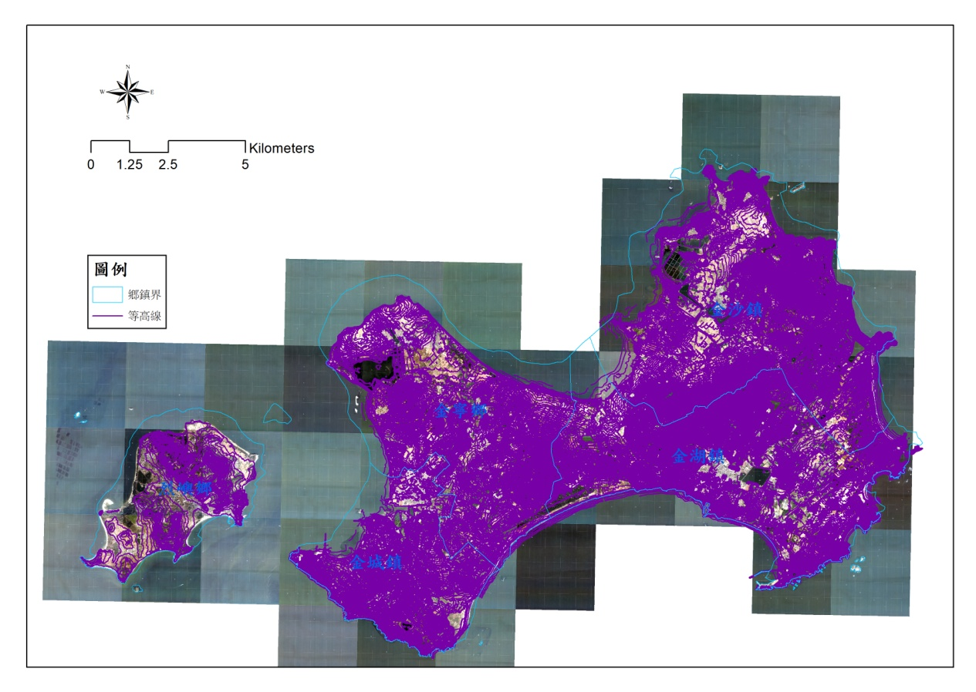
圖2金門縣等高線圖
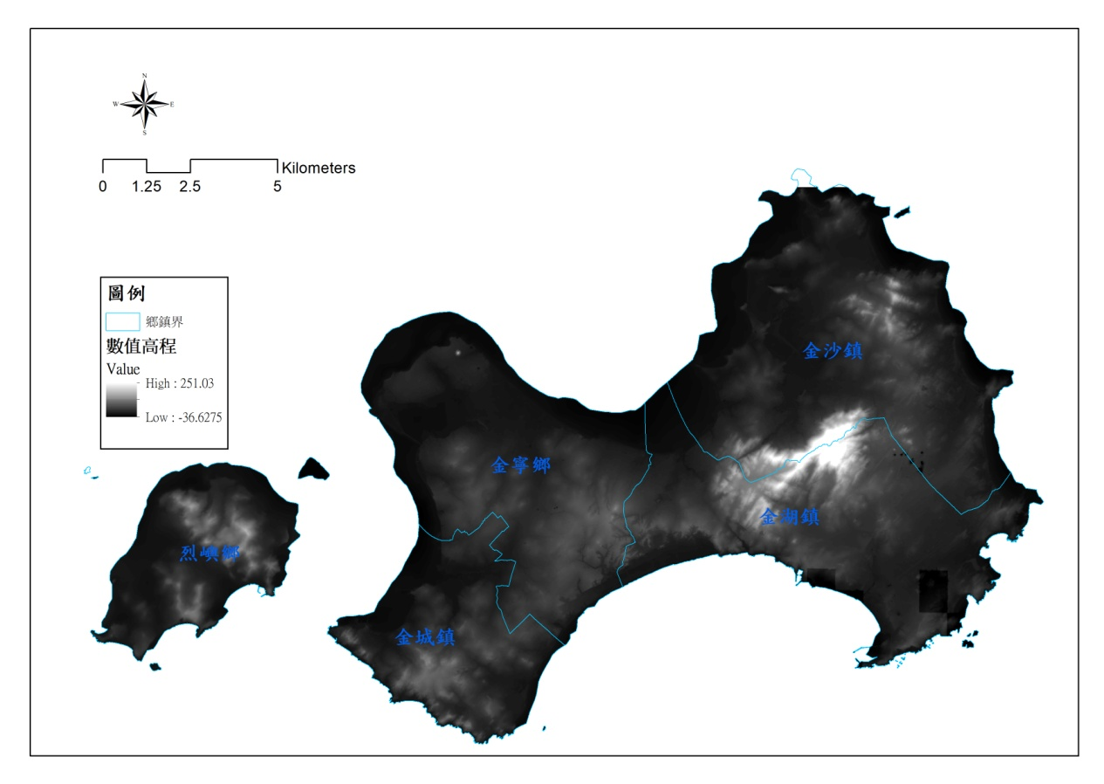
圖3金門縣數值高程模型圖
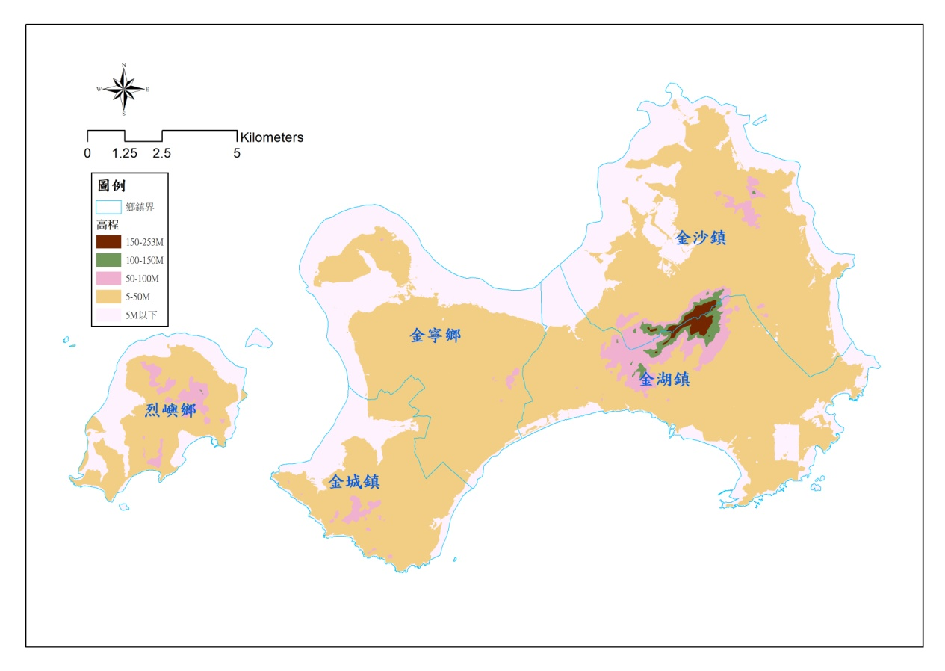
圖4金門縣高程分析圖
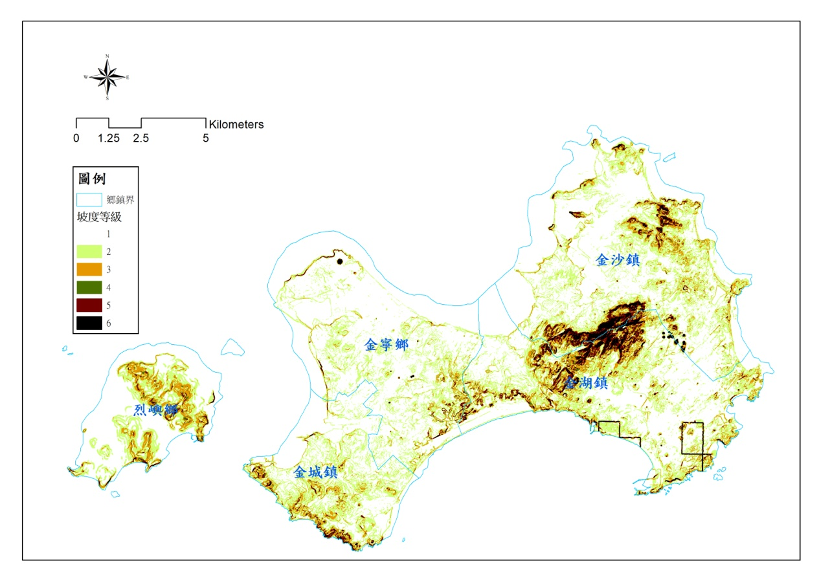
圖5金門縣坡度等級分析圖

肆、相關圖冊

一、鄉鎮山坡地範圍圖(通用電子地圖為底圖)

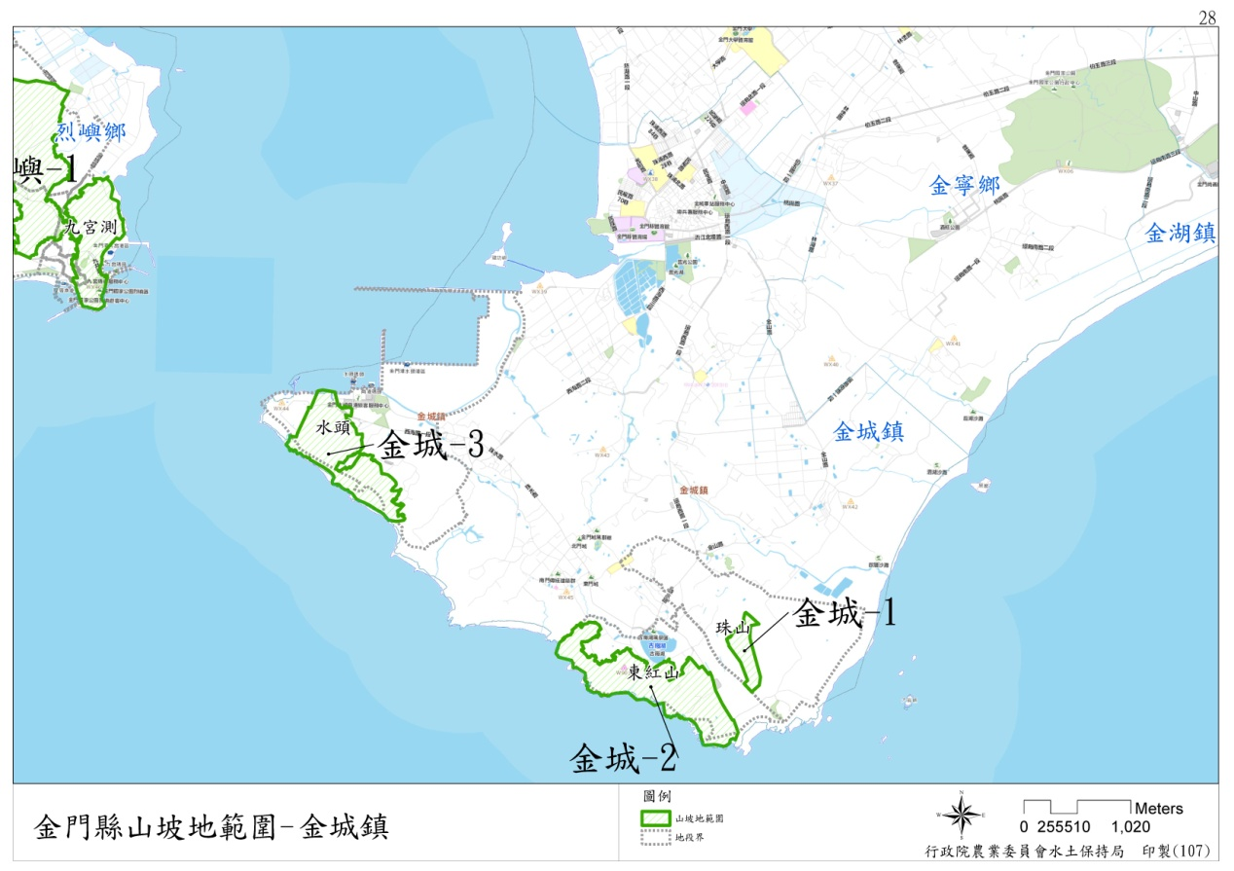
圖6金門縣金城鎮山坡地範圍位置圖
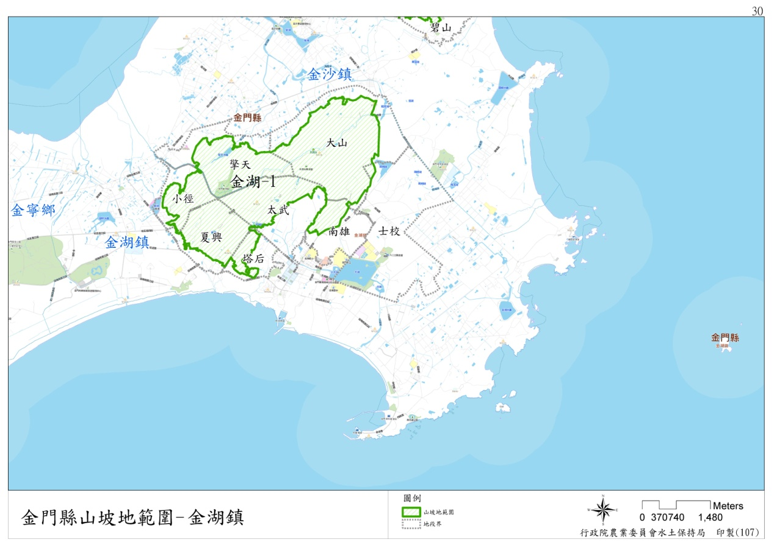

圖7金門縣金湖鎮山坡地範圍位置圖
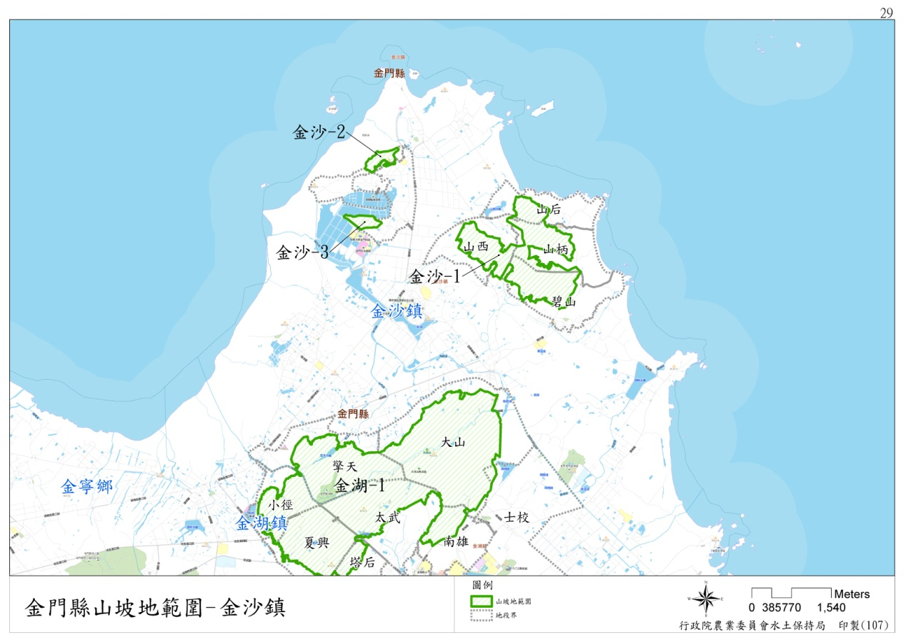
圖8金門縣金沙鎮山坡地範圍位置圖
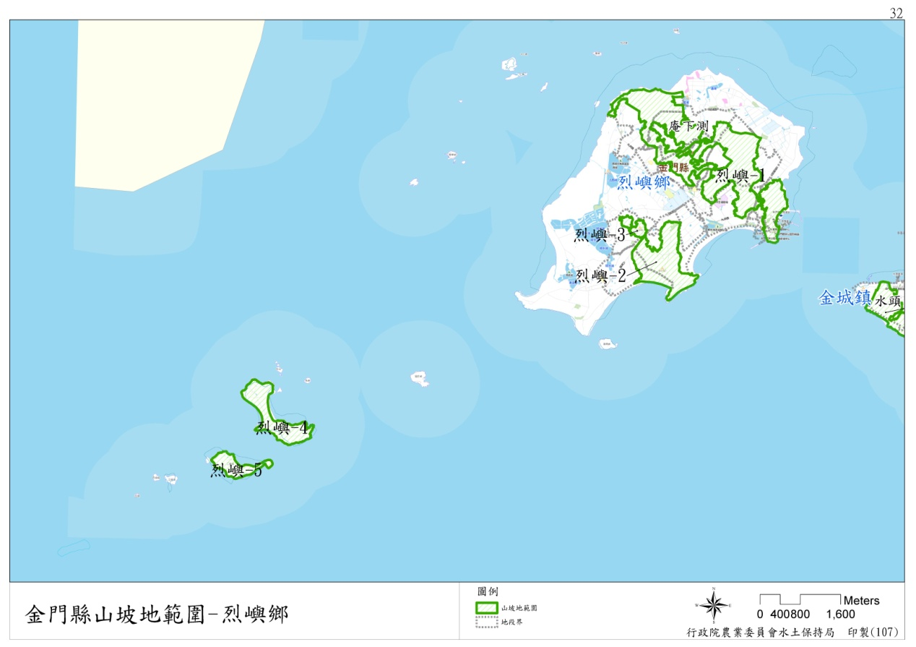
圖9金門縣烈嶼鄉山坡地範圍位置圖

二、地段山坡地範圍圖(五千分之一基本圖為底圖)

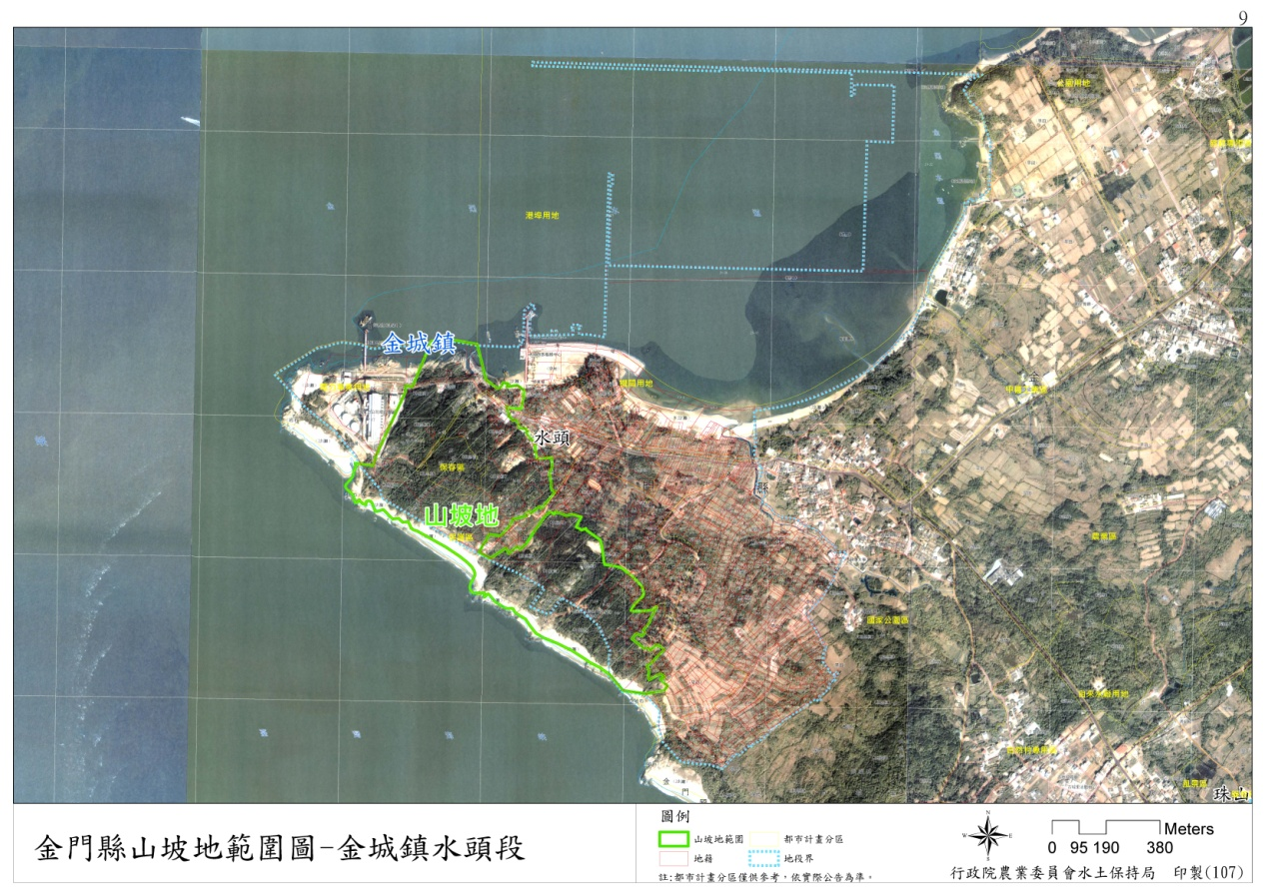
圖10金門縣山坡地範圍圖-金城鎮水頭段
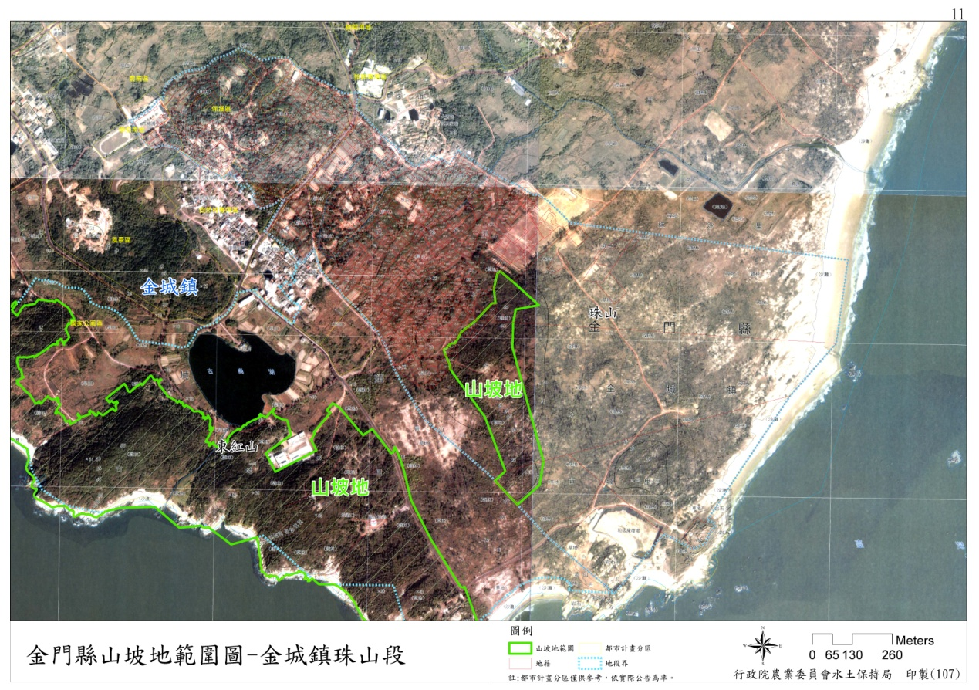
圖11金門縣山坡地範圍圖-金城鎮珠山段
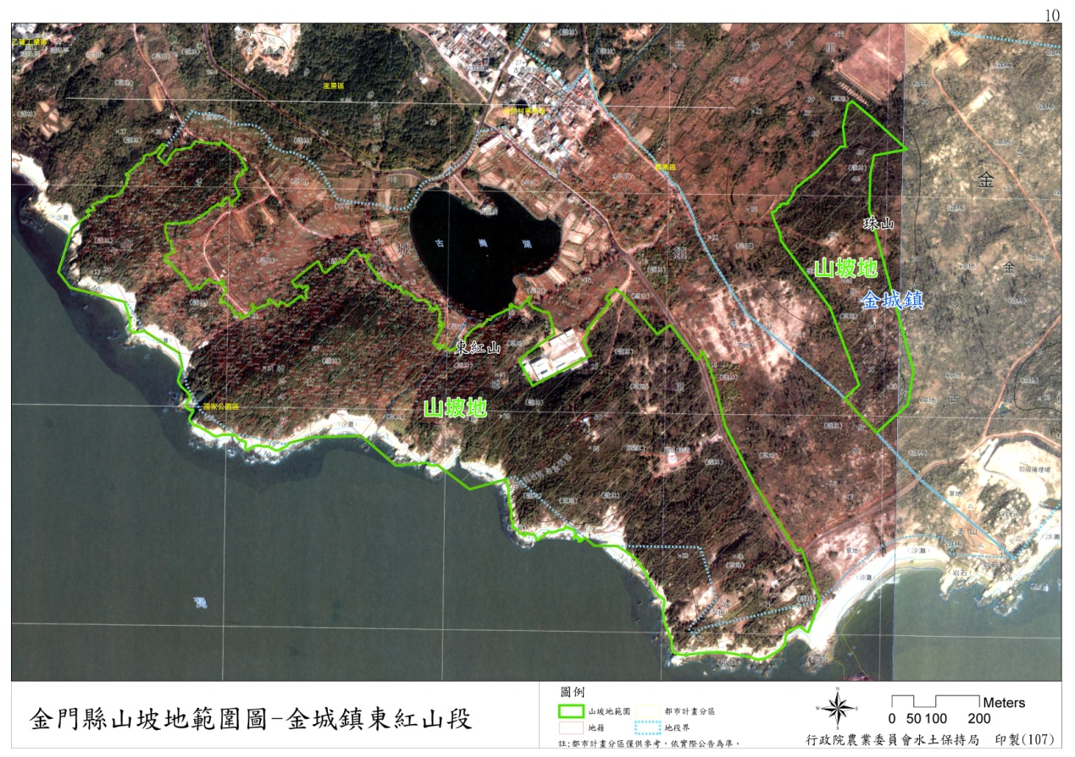
圖12金門縣山坡地範圍圖-金城鎮東紅山段
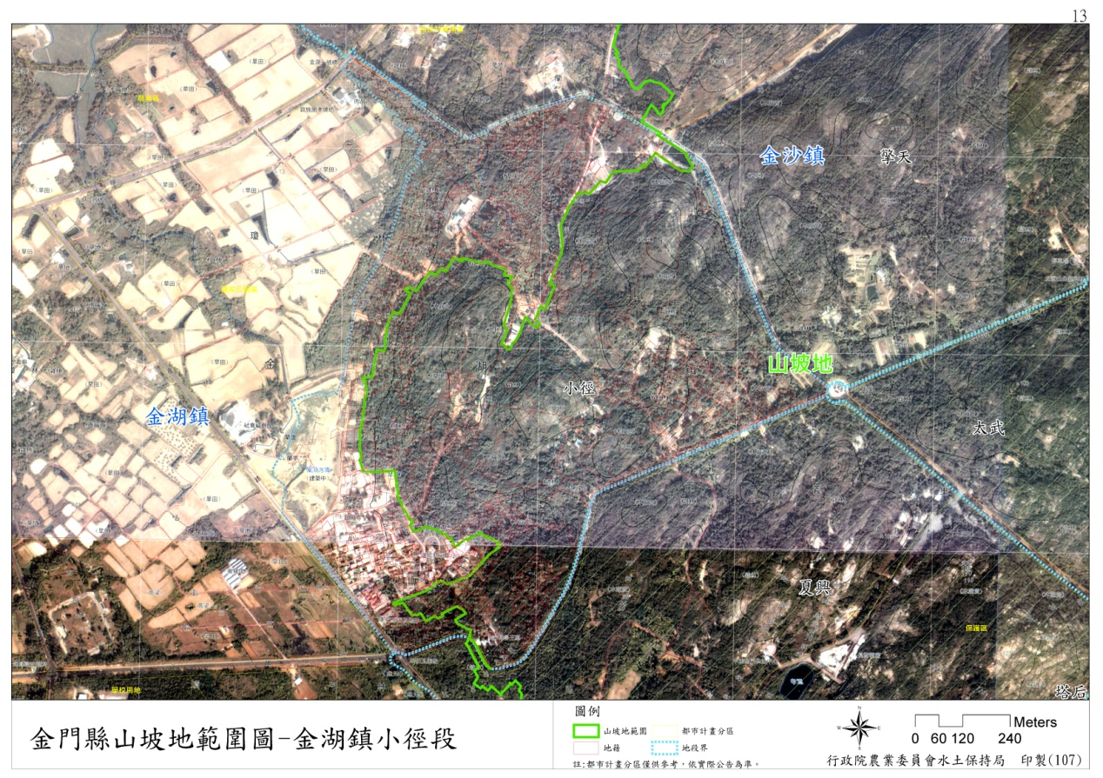
圖13金門縣山坡地範圍圖-金湖鎮小徑段
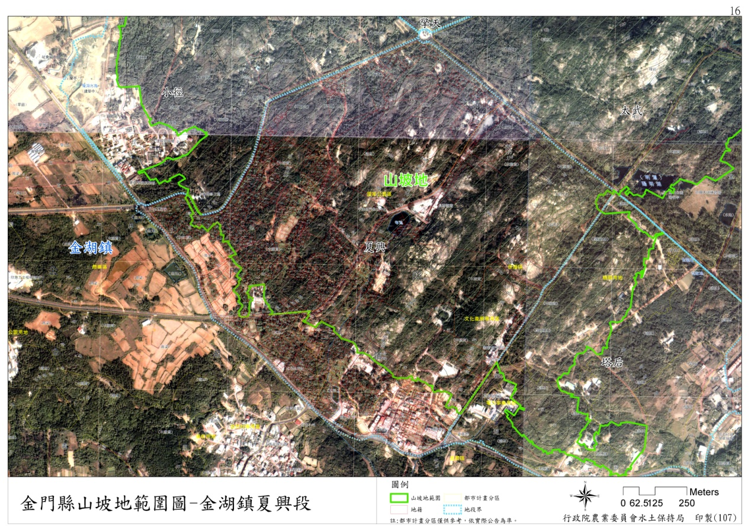
圖14金門縣山坡地範圍圖-金湖鎮夏興段
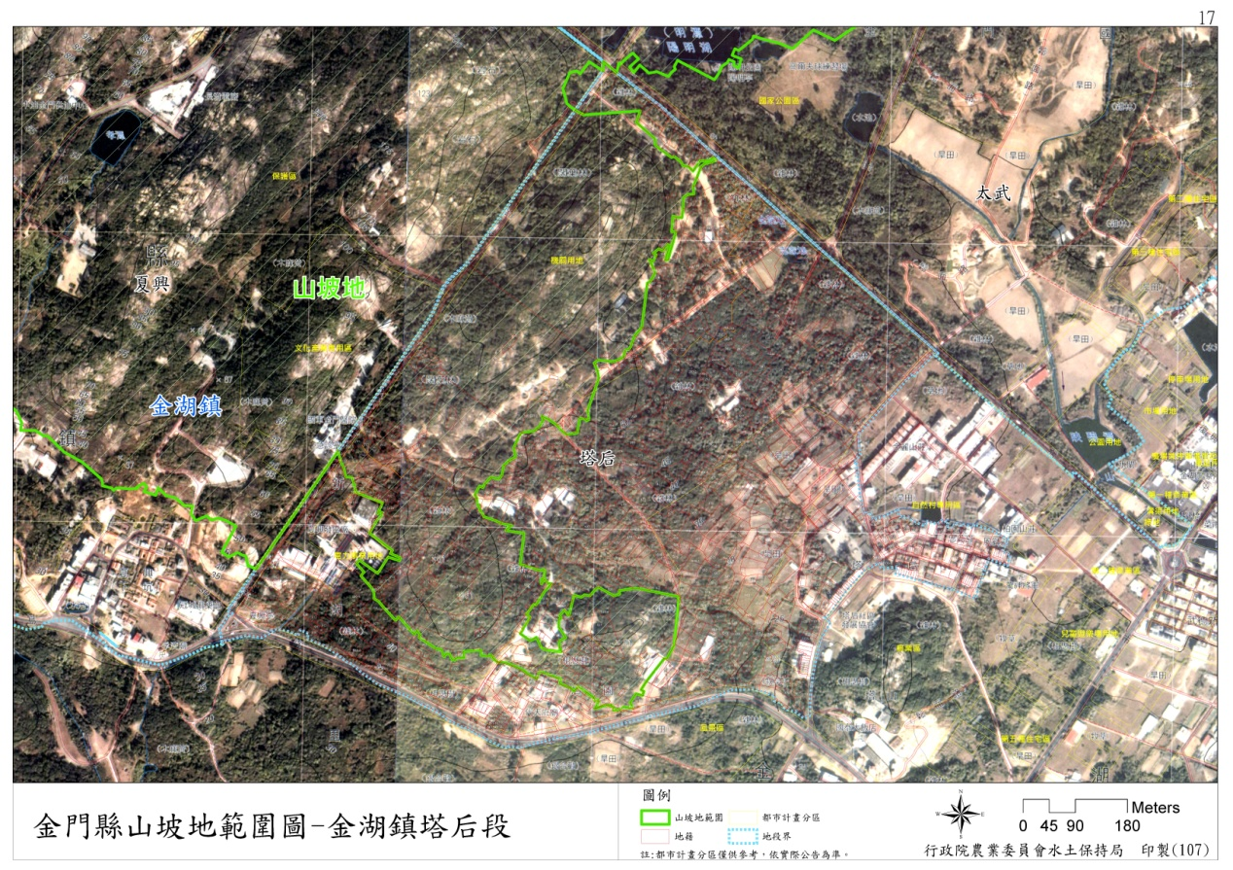
圖15金門縣山坡地範圍圖-金湖鎮塔后段
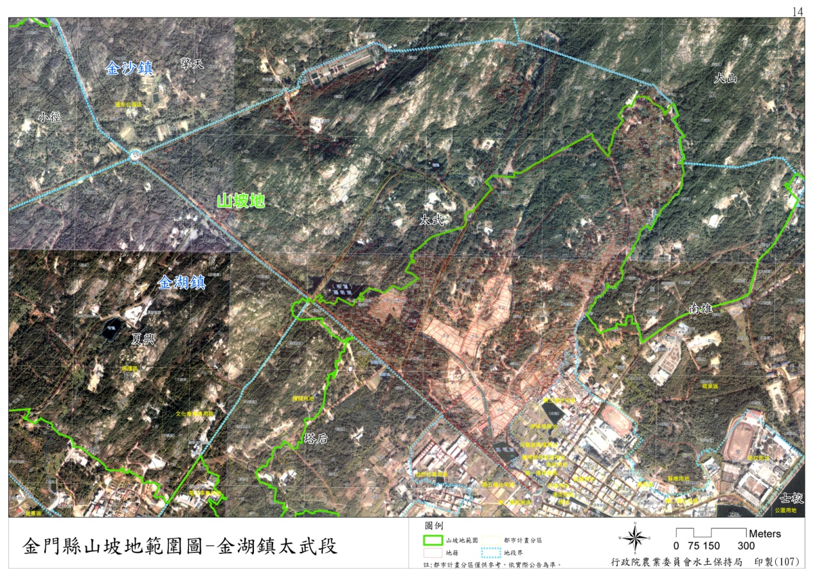
圖16金門縣山坡地範圍圖-金湖鎮太武段
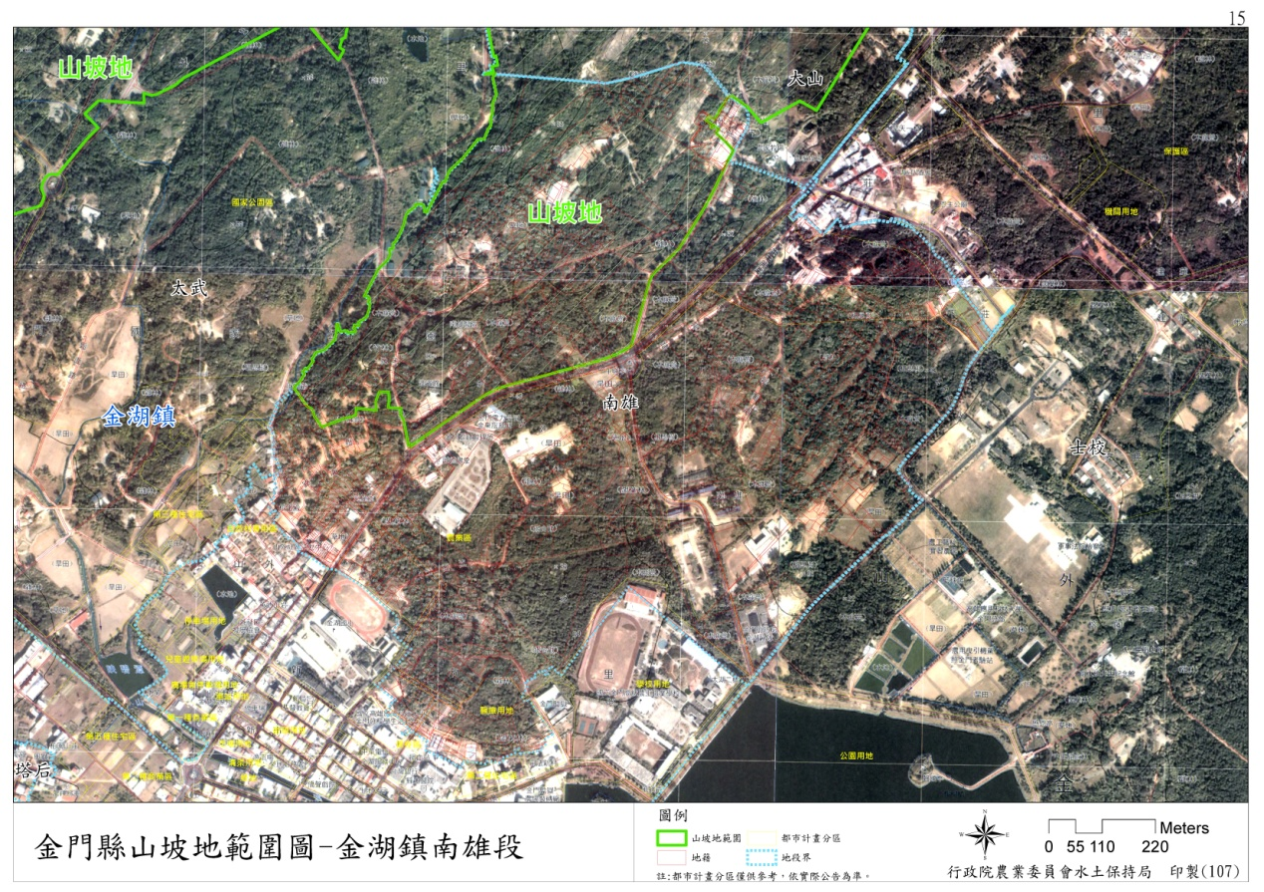
圖17金門縣山坡地範圍圖-金湖鎮南雄段
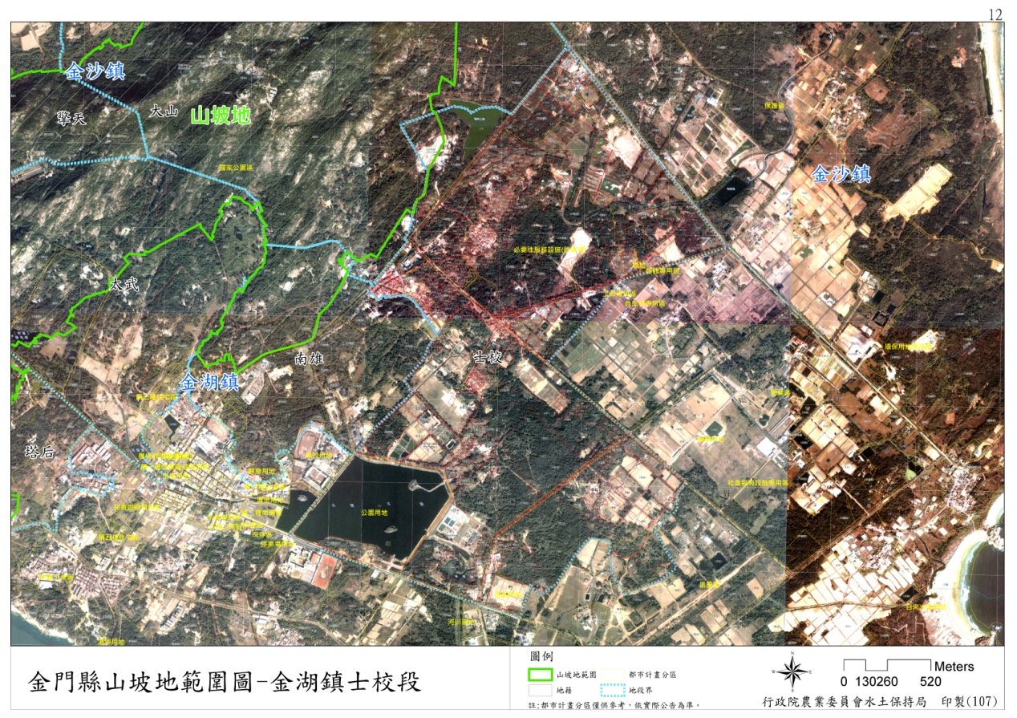
圖18金門縣山坡地範圍圖-金湖鎮士校段
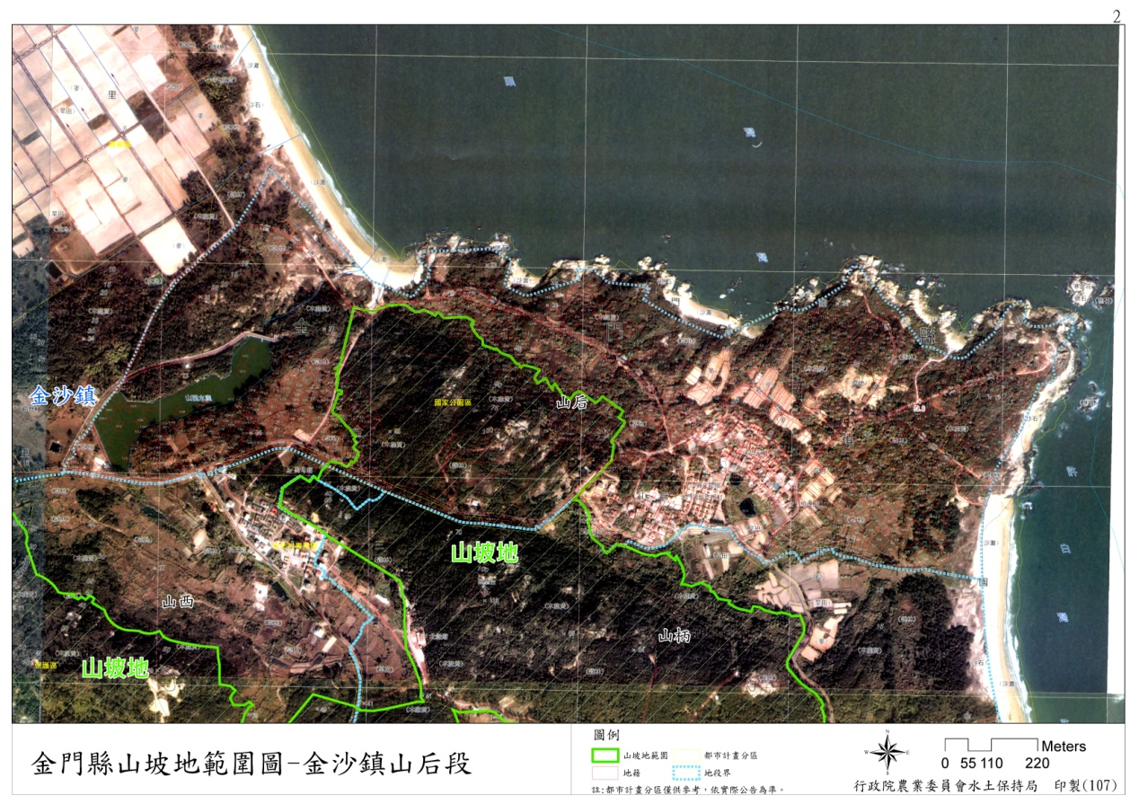
圖19金門縣山坡地範圍圖-金沙鎮山后段
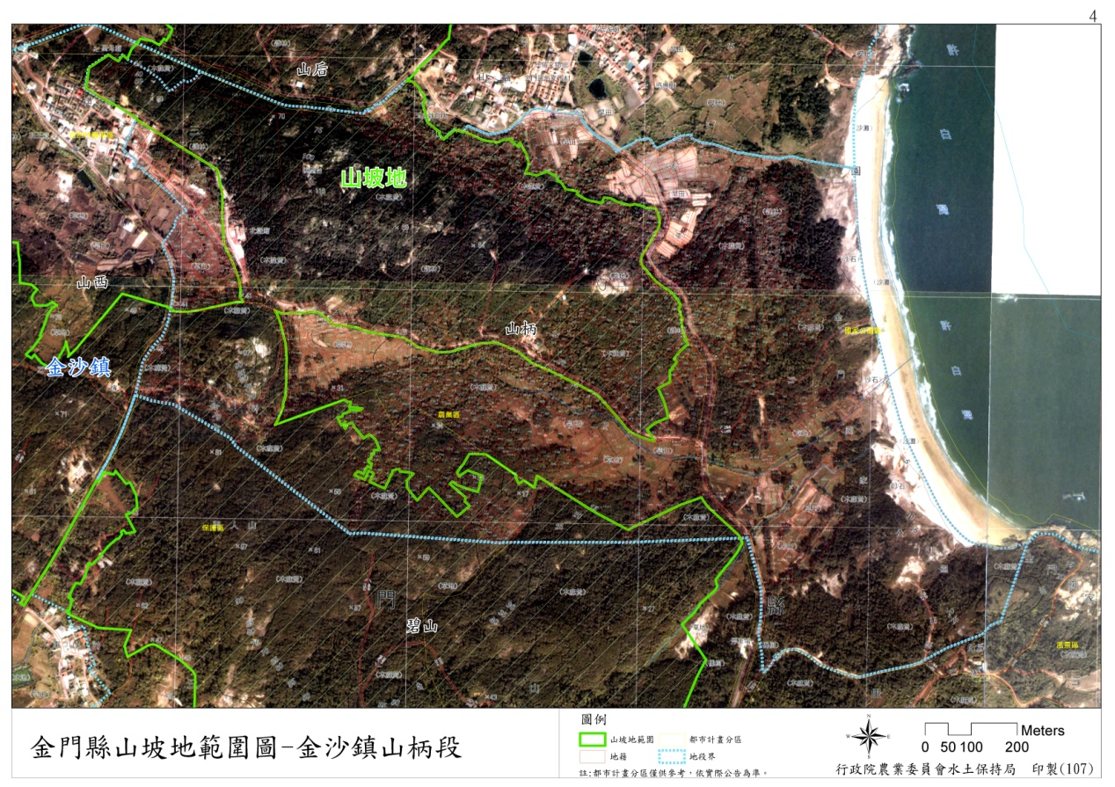
圖20金門縣山坡地範圍圖-金沙鎮山柄段
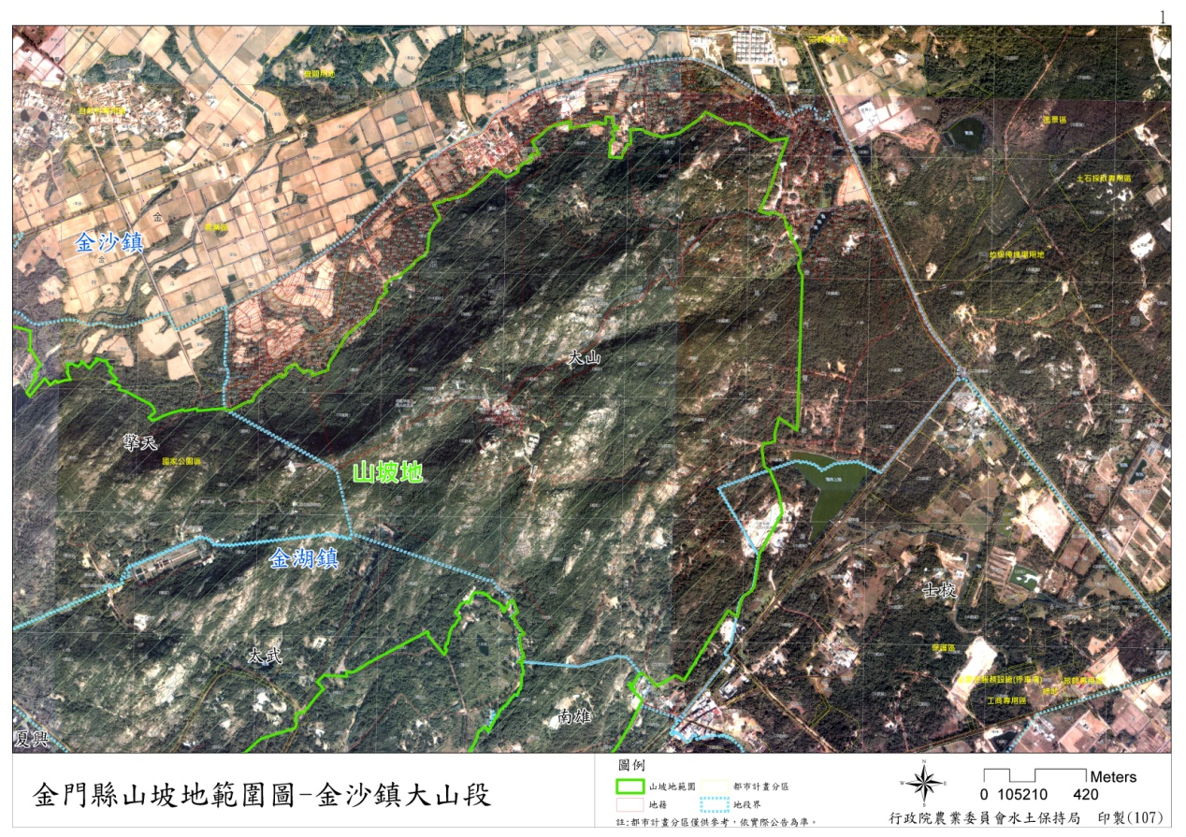
圖21金門縣山坡地範圍圖-金沙鎮大山段
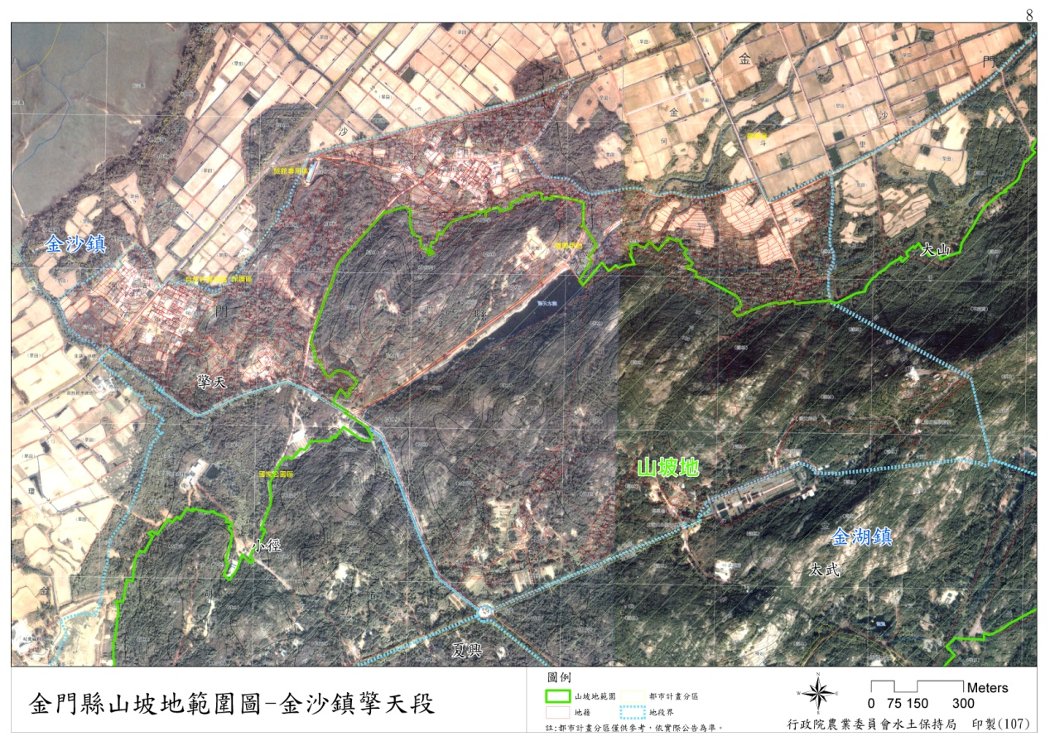
圖22金門縣山坡地範圍圖-金沙鎮擎天段
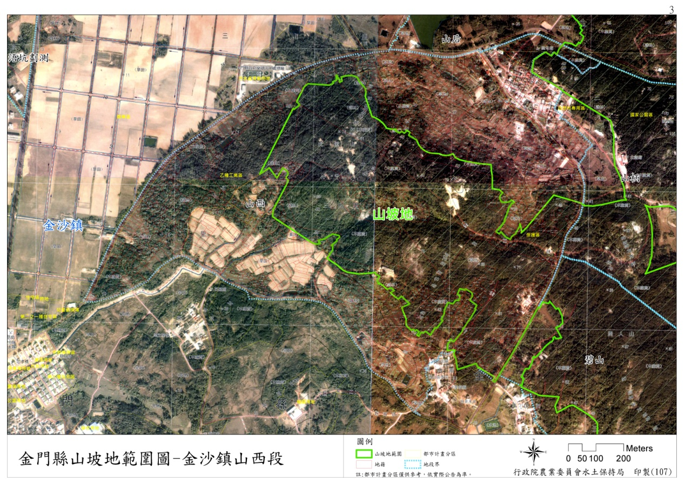
圖23金門縣山坡地範圍圖-金沙鎮山西段
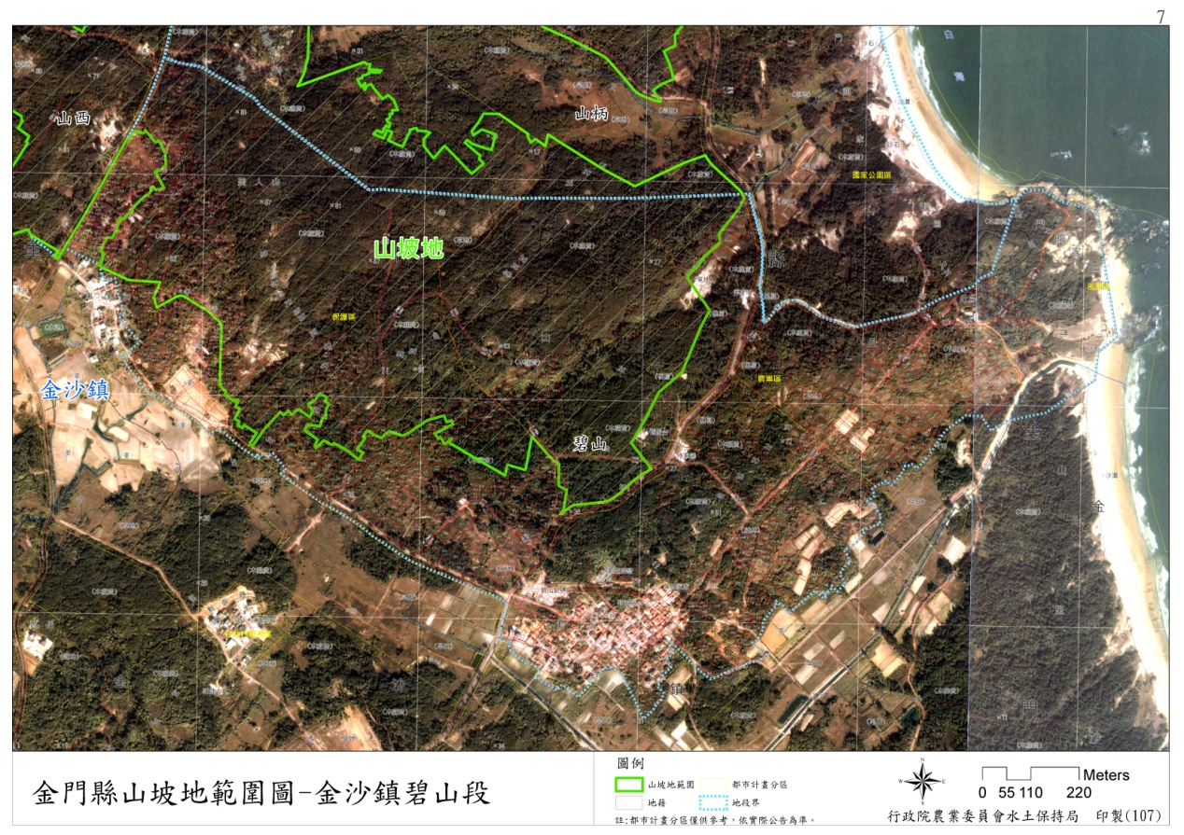
圖24金門縣山坡地範圍圖-金沙鎮碧山段
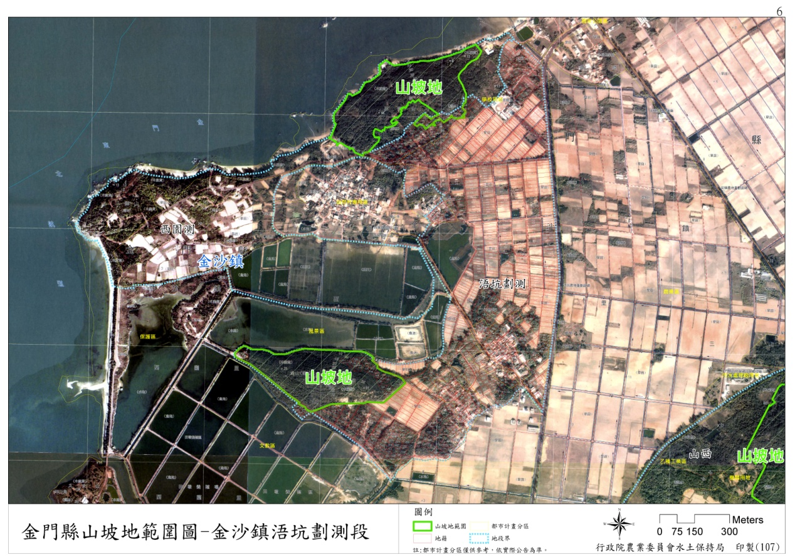
圖25金門縣山坡地範圍圖-金沙鎮浯坑劃測段
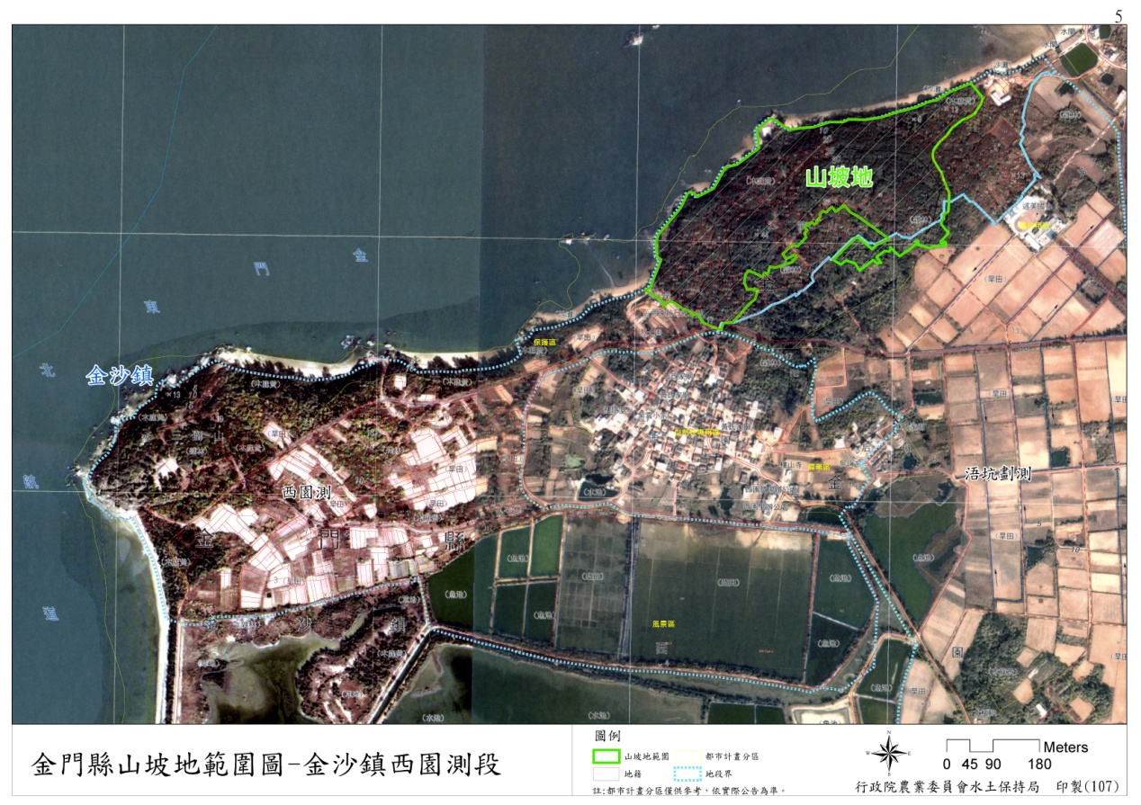
圖26金門縣山坡地範圍圖-金沙鎮西園測段
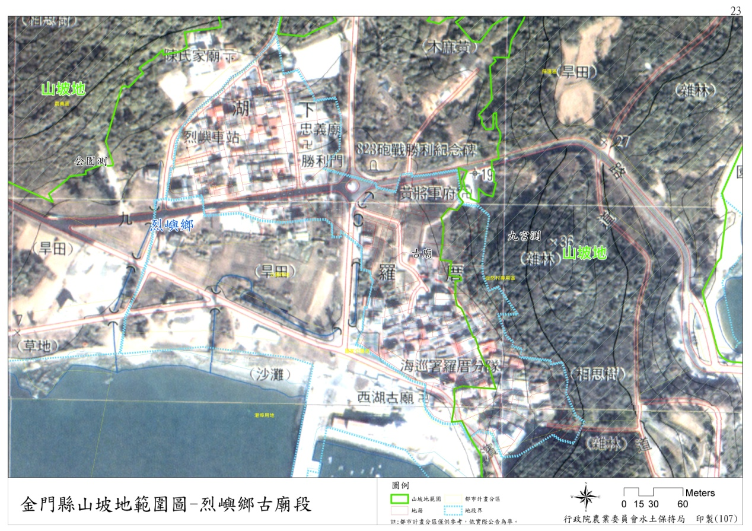
圖27金門縣山坡地範圍圖-烈嶼鄉古廟段
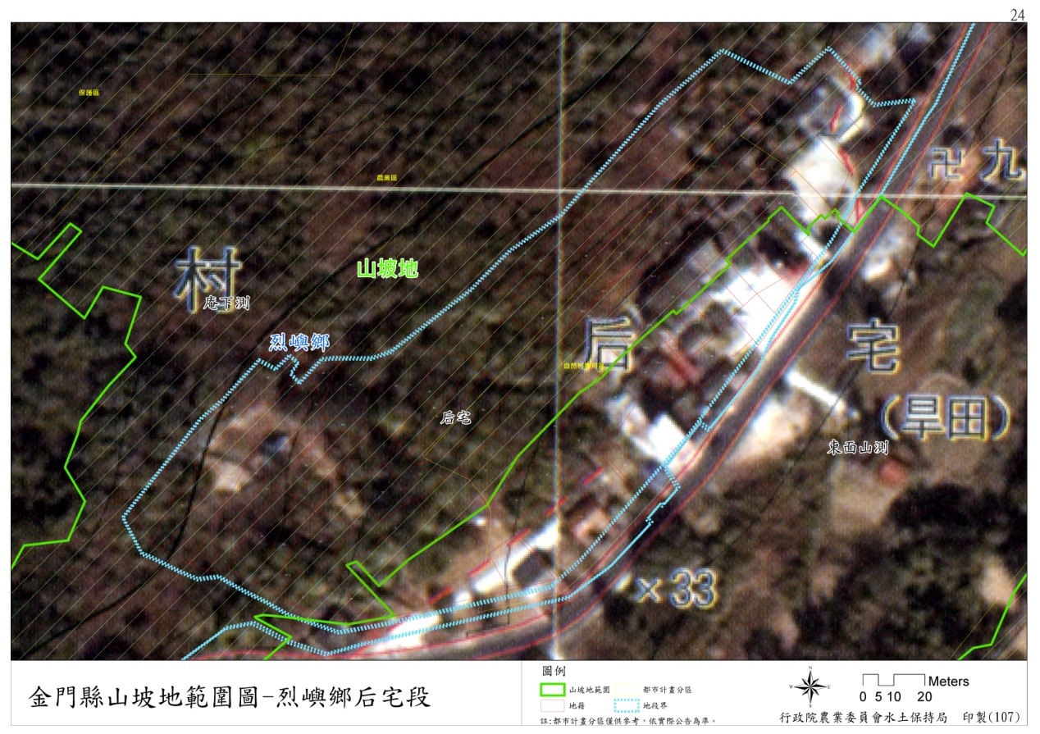
圖28金門縣山坡地範圍圖-烈嶼鄉后宅段
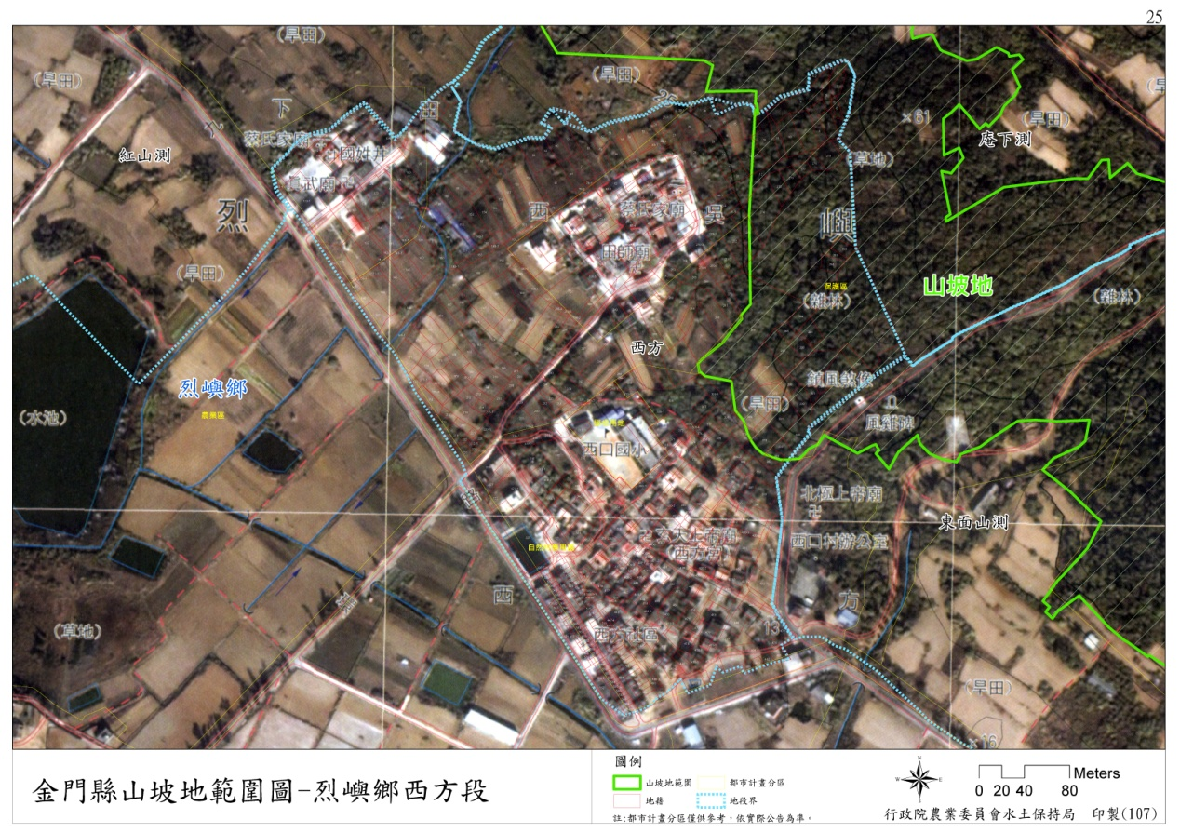
圖29金門縣山坡地範圍圖-烈嶼鄉西方段
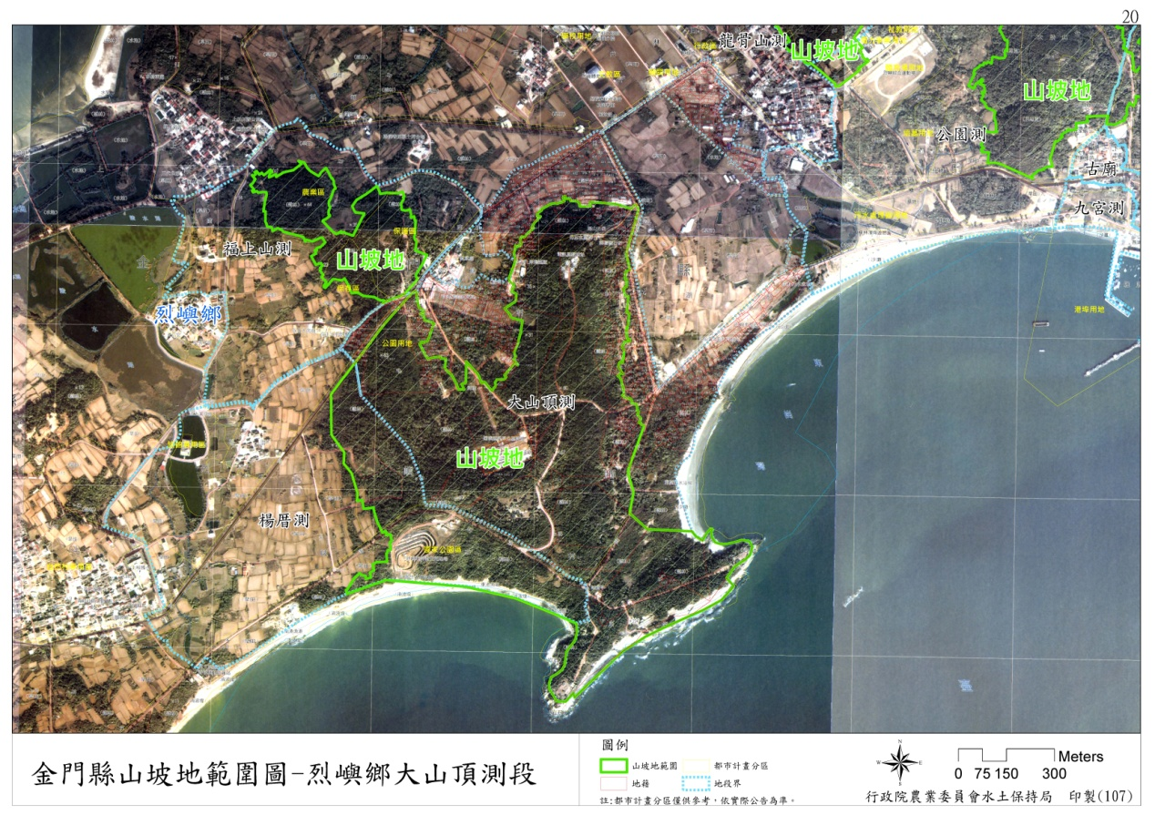
圖30金門縣山坡地範圍圖-烈嶼鄉大山頂測段
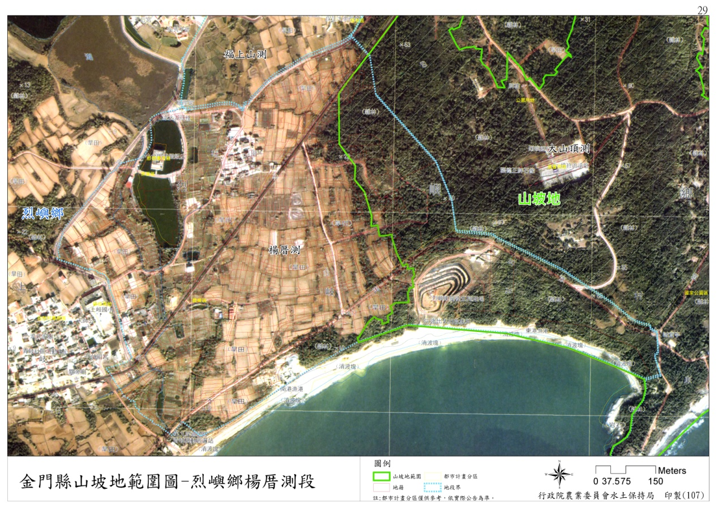
圖31金門縣山坡地範圍圖-烈嶼鄉楊厝測段
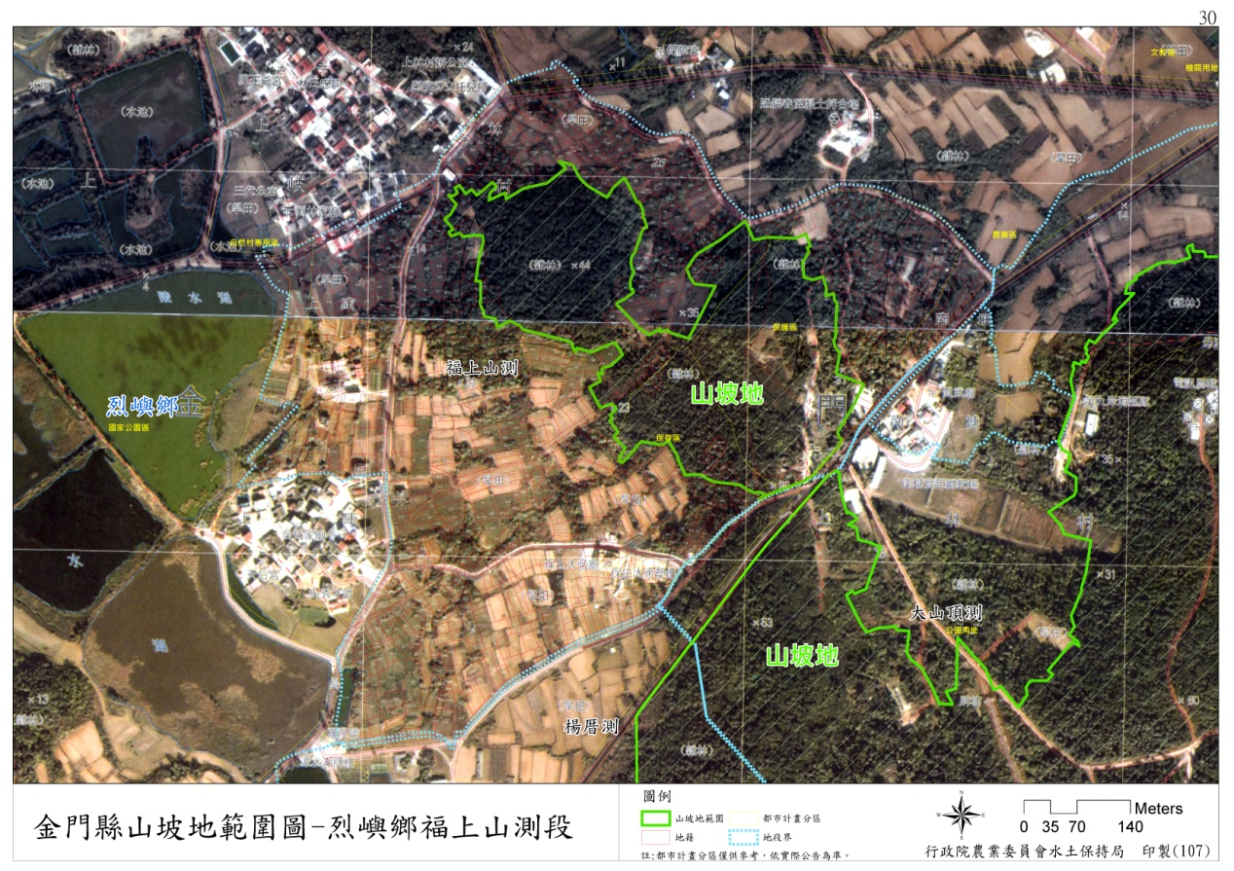
圖32金門縣山坡地範圍圖-烈嶼鄉福上山測段
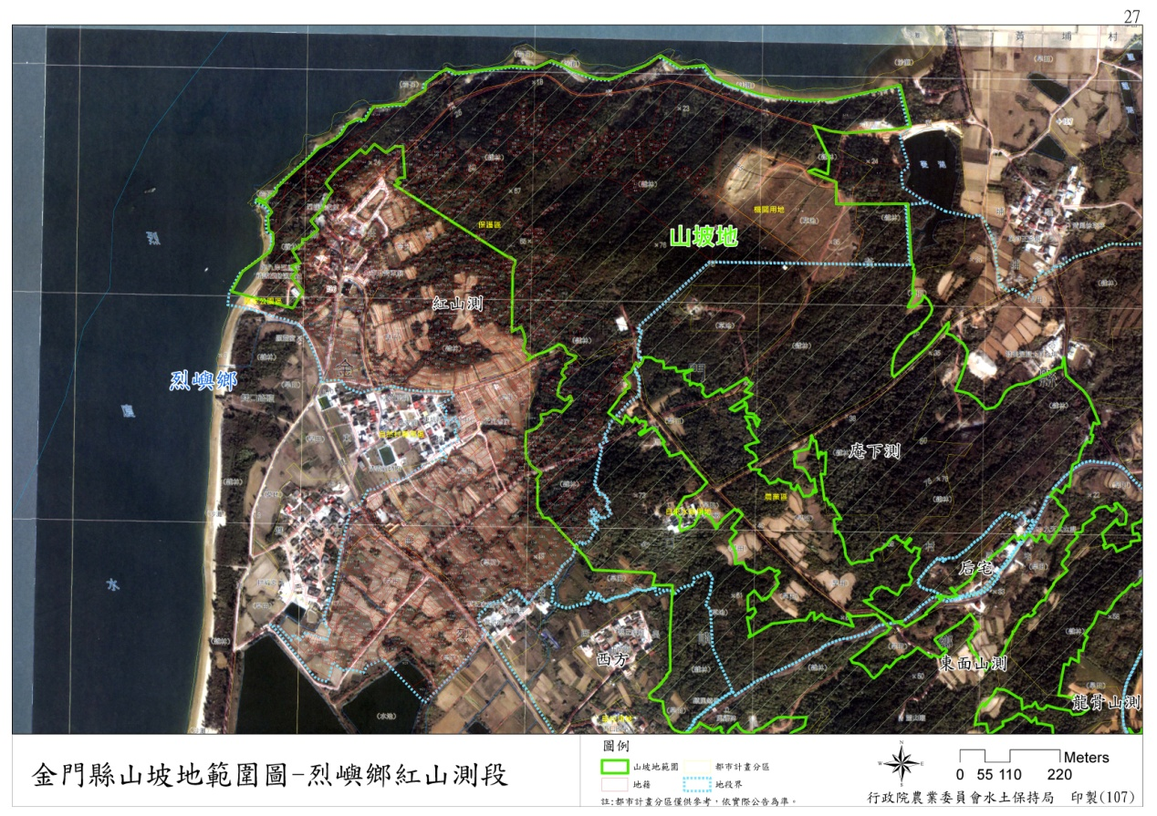
圖33金門縣山坡地範圍圖-烈嶼鄉紅山測段
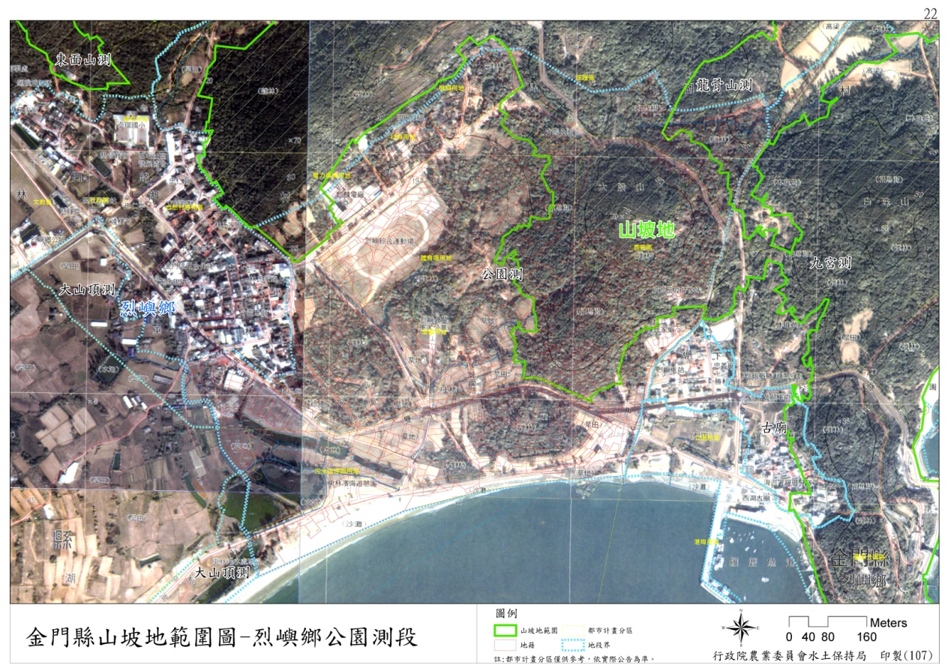
圖34金門縣山坡地範圍圖-烈嶼鄉公園測段
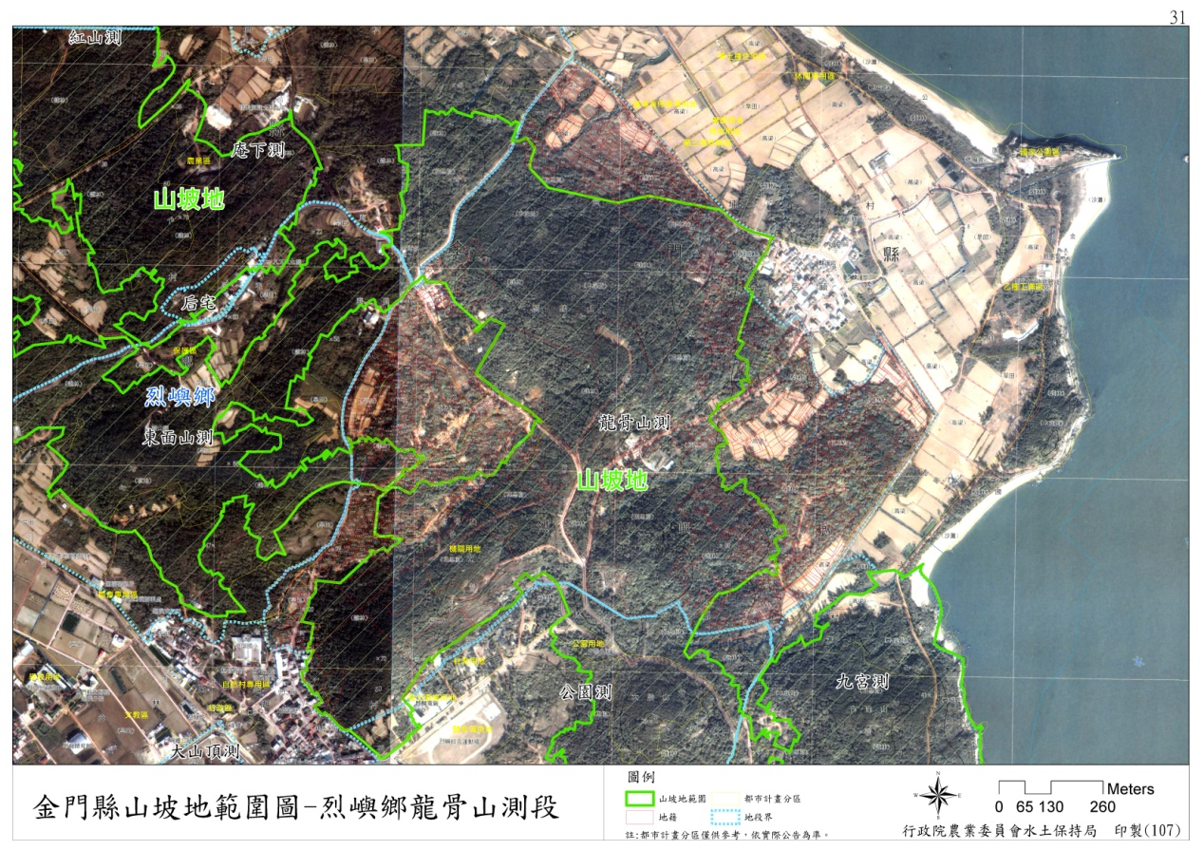
圖35金門縣山坡地範圍圖-烈嶼鄉龍骨山測段
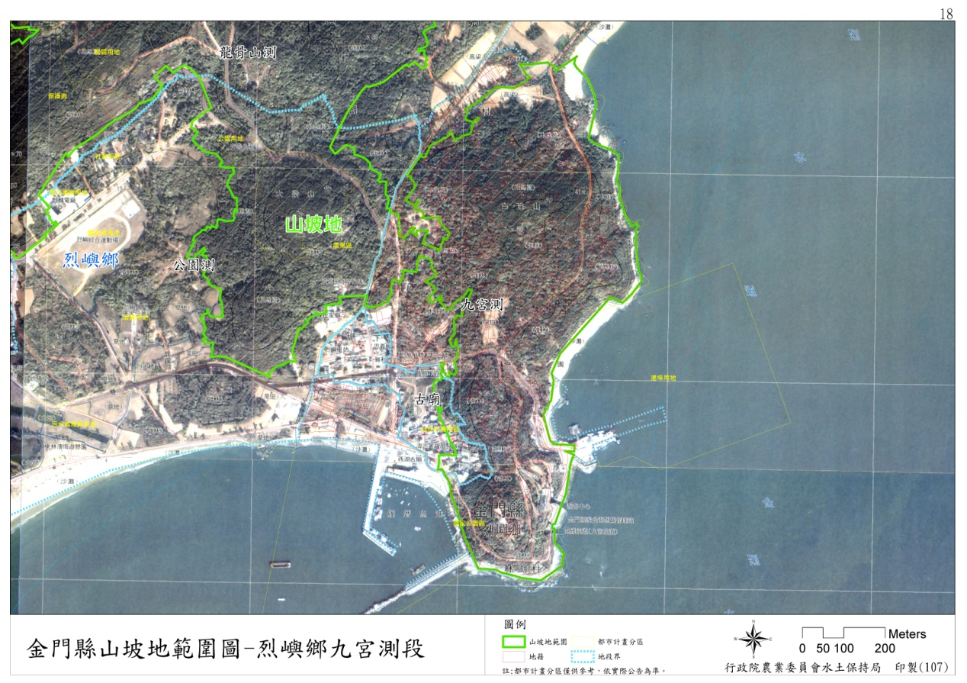
圖36金門縣山坡地範圍圖-烈嶼鄉九宮測段
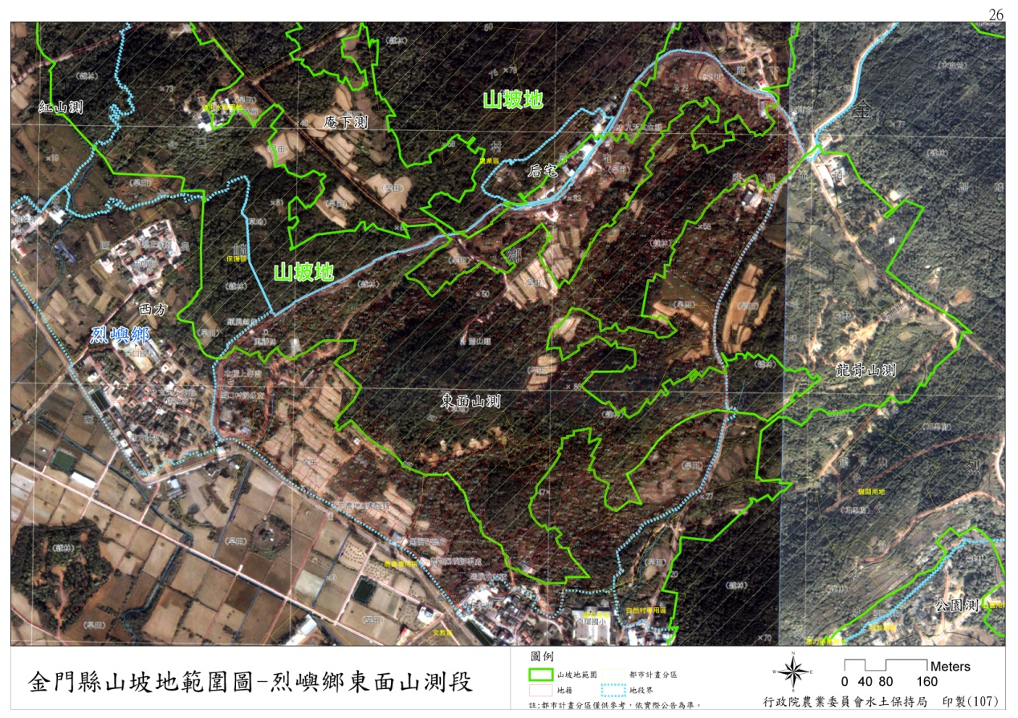
圖37金門縣山坡地範圍圖-烈嶼鄉東面山測段
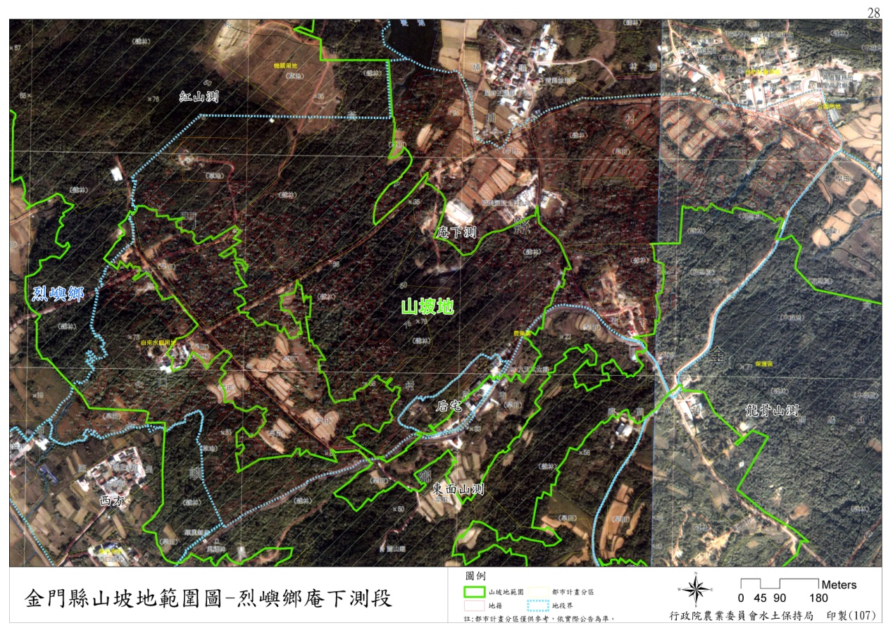
圖38金門縣山坡地範圍圖-烈嶼鄉庵下測段
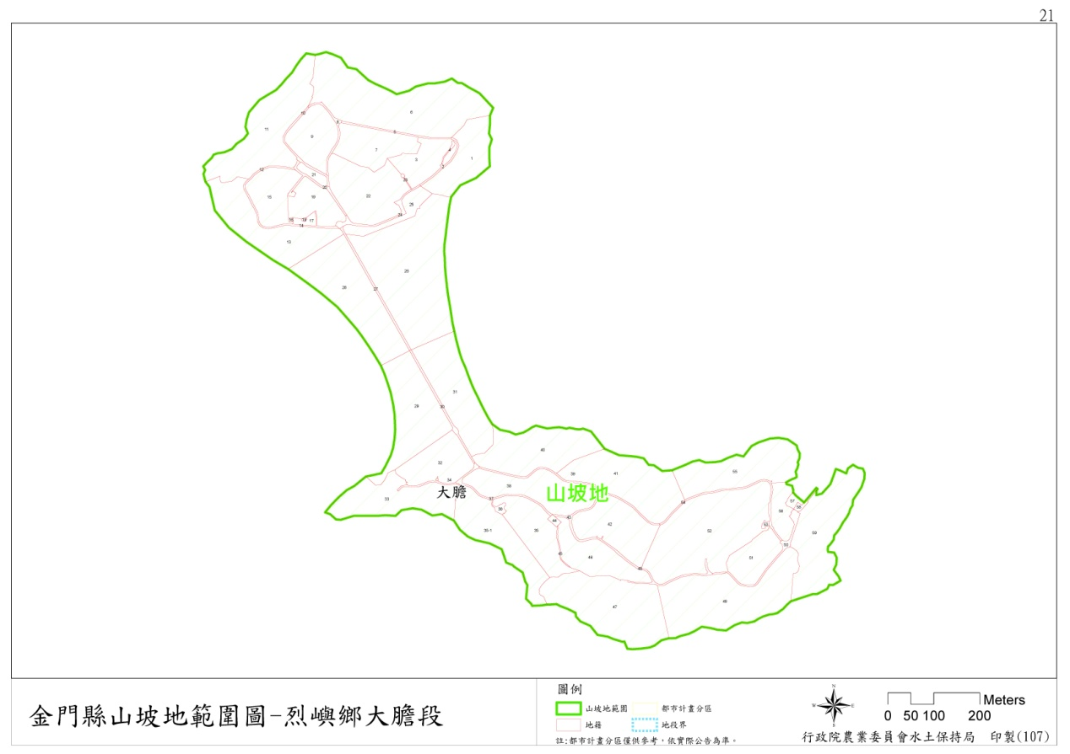
圖39金門縣山坡地範圍圖-烈嶼鄉大膽段
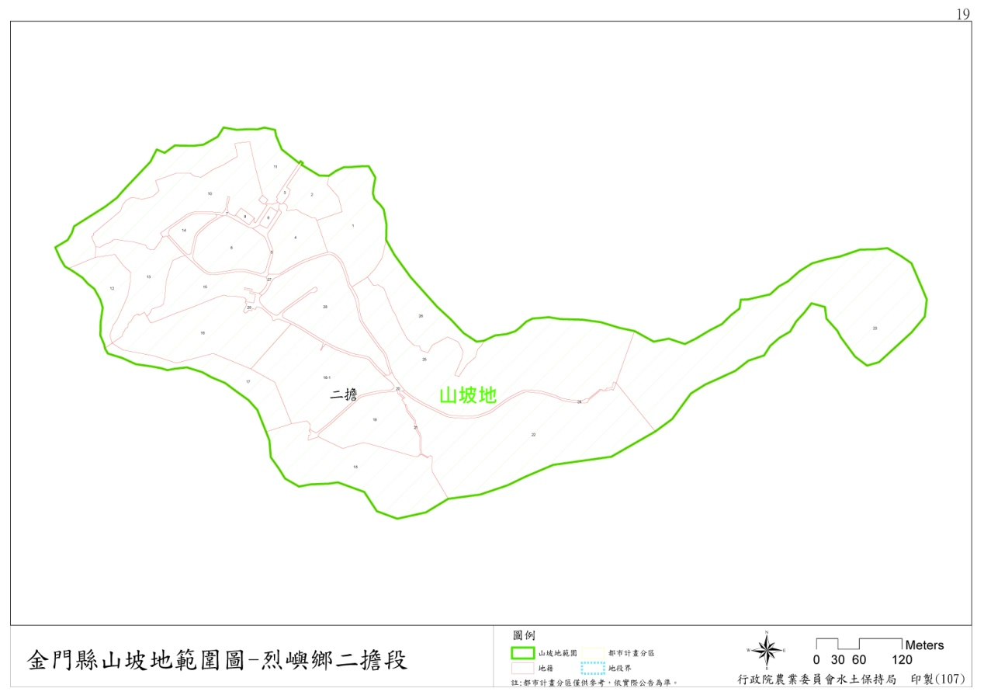圖40金門縣山坡地範圍圖-烈嶼鄉二擔段

伍、地段土地清冊
鄉鎮 | 地段 | 地號 | 筆數 | 山坡地面積(公頃) | 山坡地  註記
金沙 | 大山 | 20,323,324,325,342,343,344,345,346,352,353,354,355,356,357,358,359,360,361,362,363,364,366,371,372,373,374,375,376,377,378,379,380,381,382,383,384,385,386,387,388,389,390,391,392,393,394,395,396,397,398,399,400,401,402,403,404,405,407,408,437,438,585,586,587,588,589,946,947,948,20-1,21-1,22-1,19-2,22-2,19-3,22-3,22-4,22-6,25-6,22-8,118-1,126-1,126-2,126-3,126-4,126-5,126-6,173-10,173-11,173-12,173-14,173-15,173-16,173-18,173-19,173-32,173-33,173-40,173-41,173-6,173-7,173-8,300-5,300-6,343-1,365-3,370-1,370-4,370-5,370-6,370-7,381-1,381-2,381-3,384-1,391-1,391-2,391-3,391-4,391-5,391-6,394-1,395-1,395-2,396-1,396-2,396-4,397-1,397-10,397-11,397-2,397-5,397-6,397-7,397-8,397-9,400-1,404-1,404-2,404-3,404-4,404-5,404-6,404-7,405-1,408-1,580-1,580-4,589-1,908-1,946-1 | 152 | 317.99 | 山坡地
金沙 | 大山 | 173-27,173-34 | 2 | 15.90 | 部分為山坡地
金沙 | 山后 | 755,756,759,760,761,773,774,775,776,777,786,787,788,789,790,804,805,806,807,808,809,810,811,812,813,814,815,816,817,818,819,820,821,822,823,824,825,826,827,828,829,830,831,832,833,834,835,836,837,838,839,840,841,979,980,981,982,983,984,987,1009,1010,1011,1012,1013,1014,1015,1040,1044,1045,1051,1052,1053,1054,1060,1133,1134,1135,1136,1137,1138,1139,1140,1141,1142,1143,1144,1145,1146,1147,1148,1160,1163,1165,1166,1167,1168,1169,1170,1171,1172,1173,1174,1175,1176,1177,1181,1182,1009-1,1016-1,1045-1,1046-3,1047-1,1052-1,1053-1,1070-2,1138-1,1144-1,1145-1,1165-1,1170-1,1182-1,775-1,804-2,804-3,804-5,804-7,804-8,819-1,825-1,838-1,838-10,838-11,838-2,838-3,838-4,838-5,838-6,838-7,838-8,838-9,839-1,839-2,840-2,980-1,984-1 | 146 | 24.21 | 山坡地
金沙 | 山后 | 810-1 | 1 | 0.29 | 部分為山坡地
金沙 | 山西 | 425,496,497,498,499,500,501,502,503,530,531,532,533,534,535,536,537,538,539,540,541,542,543,544,567,569,570,601,602,603,604,605,606,607,608,609,610,611,612,613,614,615,616,617,618,619,620,621,622,623,624,633,634,635,637,638,639,640,641,642,643,644,645,646,647,648,649,650,651,652,653,654,655,656,657,658,659,660,661,662,663,664,665,666,667,668,669,670,671,672,673,674,675,676,677,678,679,680,681,682,683,684,685,686,687,689,690,691,692,693,694,695,696,697,698,699,700,701,702,703,704,705,706,707,708,709,710,711,712,713,714,715,716,717,718,719,720,721,722,723,724,725,726,727,728,729,730,731,732,733,734,735,736,737,738,739,740,741,742,743,744,745,746,747,748,765,766,767,768,769,770,771,772,773,775,778,779,786,787,788,789,790,791,792,793,794,795,796,797,798,799,800,801,802,803,804,805,806,807,808,809,810,811,812,813,821,822,824,825,826,827,828,829,830,832,836,837,838,839,840,841,842,843,844,845,846,847,848,849,850,851,852,854,860,861,971,972,1012,1013,1014,1015,1016,1017,1093,1094,1103,1104,1105,1106,1107,1111,1112,1113,1114,1115,1116,1117,1119,1120,1121,1122,1123,1124,1125,1126,1127,1128,1129,1130,1131,1132,1133,1134,1135,1136,1137,1138,1139,1140,1141,1142,1143,1144,1145,1146,1147,1148,1149,1150,1151,1152,1153,1154,1155,1156,1157,1158,1159,1160,1161,1162,1163,1164,1165,1166,1167,1168,1169,1170,1171,1172,1173,1174,1175,1176,1177,1178,1179,1180,1184,1185,1186,1191,1192,1359,1473,1474,1479,1483,1626,1760,1761,1762,1763,1764,1765,1766,1122-1,1122-2,1122-3,1135-1,1141-1,1483-1,337-2,337-3,337-6,530-1,535-1,535-2,539-1,543-2,570-2,570-3,645-1,677-1,687-1,687-2,696-1,700-1,710-1,728-1,767-1,791-1,828-1,828-2,828-3 | 366 | 36.73 | 山坡地
金沙 | 山西 | 336,337,338,363,364,365,423,424,426,493,494,495,545,546,565,566,568,571,591,592,632,831,833,834,835,853,1183,1187,1188,1357,1480,1625,1627,1006-1,1030-1,1042-1,1042-4,1092-1,1188-1,1496-1,1623-1,337-1,337-4,337-5,337-7,337-8,363-1,426-1,488-1,499-1,543-1,570-1,592-1,601-1,804-1,851-1,972-1,985-1 | 58 | 22.49 | 部分為山坡地
金沙 | 山柄 | 100,101,102,103,104,105,106,107,108,109,110,111,112,113,114,115,116,117,118,119,120,121,122,123,124,125,126,127,128,129,130,131,132,133,134,135,136,137,138,139,140,141,142,143,144,145,146,147,148,149,150,151,152,153,154,155,156,157,158,159,160,161,162,163,164,165,166,167,168,169,170,171,172,173,175,176,285,288,289,290,291,292,293,294,295,296,297,298,300,301,302,303,304,305,306,307,308,309,310,311,312,313,314,315,316,317,318,319,320,321,322,323,324,325,326,327,328,329,330,331,332,333,335,336,337,338,339,340,341,342,343,344,345,346,347,348,349,350,351,352,353,354,355,356,357,358,359,442,443,444,445,446,447,448,449,451,452,453,454,455,456,457,458,459,460,461,462,463,464,465,466,467,468,469,470,471,472,473,474,475,476,477,478,479,480,481,482,483,484,485,486,487,488,489,490,491,492,493,494,495,496,497,498,499,500,501,502,576,577,578,579,580,581,582,583,584,585,586,587,588,589,590,591,592,593,594,595,596,597,598,600,601,602,603,604,605,606,607,608,609,610,611,612,613,614,615,616,617,618,619,620,668,669,670,671,672,673,674,675,676,677,678,679,680,681,682,683,684,685,686,687,688,689,690,691,692,693,694,695,696,697,698,699,700,701,702,703,704,705,706,707,708,709,710,711,712,713,714,715,716,717,718,719,720,721,722,723,724,725,726,727,728,729,730,731,732,733,734,735,736,737,738,739,740,741,742,743,748,749,750,751,752,753,754,755,756,757,758,759,760,761,762,763,764,765,766,768,774,775,776,777,778,779,780,781,782,783,784,785,786,787,788,789,790,791,792,793,803,804,805,806,807,860,861,862,863,864,865,866,892,893,894,896,897,898,1074,1129,1131,1132,1133,1134,1135,1136,1137,1138,1144,1145,1149,1154,1156,1157,1158,1159,1160,1161,1162,1163,1164,1165,1188,1189,1190,1191,1192,1193,1194,1195,1196,1197,1198,1199,1200,1201,1202,1203,1204,1207,1208,1209,1210,1211,1212,1213,1214,1215,1216,1217,1218,1219,1220,1221,1222,1223,1224,1225,1226,1227,1228,1229,1230,1246,1247,1248,1298,1299,1300,1301,1302,1303,1304,1305,1306,1307,1308,1309,1310,1311,1312,1323,1324,1325,1326,1327,1328,1329,1330,1331,1369,1373,1374,1375,1376,1446,1447,1448,1449,1450,1451,1452,1453,1454,1455,1456,1457,1458,1459,1460,1461,1462,1463,1464,1465,1466,1467,1468,1469,1470,1471,1472,1473,101-1,101-2,101-3,106-1,1071-1,110-1,1110-1,1128-2,114-1,116-1,116-3,1163-2,116-4,1166-1,1169-1,1169-3,1184-1,1184-2,1186-1,1205-1,1223-1,1232-1,1232-2,1232-5,1233-2,1233-3,1244-1,1245-1,1249-1,1250-1,1258-1,1258-2,126-1,1300-1,130-1,1307-1,1308-1,1324-1,1326-1,1326-2,1326-9,1329-1,1330-1,1332-1,1358-4,1358-5,1359-1,1366-2,1367-2,1368-1,1369-1,1370-2,1370-3,1373-1,1373-2,1374-1,1445-1,1447-1,1447-2,1447-3,1447-4,1470-1,1471-1,167-1,294-1,300-1,304-1,325-1,330-1,332-1,338-1,342-1,342-2,353-1,354-2,356-1,440-1,452-1,455-1,463-1,494-1,494-2,494-3,498-1,502-3,575-1,577-1,583-1,583-2,592-1,595-1,595-2,601-1,608-1,608-2,612-1,612-2,612-3,617-1,618-1,619-1,620-1,621-1,671-1,671-2,677-1,677-2,687-1,703-1,711-1,712-1,712-2,712-3,718-1,732-1,734-1,737-1,740-1,741-1,741-2,744-1,745-1,746-1,747-1,747-2,753-1,754-1,757-1,763-1,764-1,766-1,767-1,768-1,770-2,771-3,772-1,772-2,778-1,786-1,789-1,796-1,860-1,867-1,867-2,885-2,890-1,891-1,895-1,913-3,913-4,927-2,927-3,927-4 | 663 | 62.38 | 山坡地
金沙 | 山柄 | 1106,1107,1295,1296,1297,1436,1445,1131-1,1163-1,1297-1,1375-1,1377-1,1377-2,1436-1 | 14 | 5.04 | 部分為山坡地
金沙 | 西園測 | 25,26,30,31,70,71,77,78,79,80,81,82,83,84,85,86,87,88,89,90,91,92,93,94,96,97,98,114,115,116,117,118,119,120,121,122,123,124,125,126,127,128,129,130,131,132,133,134,135,136,137,139,162,163,164,165,166,167,168,169,170,171,172,173,174,175,176,177,178,179,180,181,182,183,184,185,186,187,188,189,190,191,192,193,194,195,196,197,198,199,200,201,202,203,204,205,206,207,208,209,210,211,212,213,214,215,216,217,218,219,220,221,222,223,224,225,226,227,228,229,230,231,232,233,234,235,70-1,70-2,70-3,70-4,70-5,70-7,70-8,70-9,85-1,96-1,98-1,127-1,131-1,167-1,173-1,178-1,191-1,194-1,200-1,211-1,214-1,219-1 | 148 | 11.25 | 山坡地
金沙 | 西園測 | 14,15,27,28,29,40,69,35-1,43-1,68-1,27-1,235-1 | 12 | 1.91 | 部分為山坡地
金沙 | 浯坑劃測 | 186,188,190,191,193,194,197,198,249,250,252,253,254,255,256,258,1175,1176,1177,1178,1179,1180,1181,1182,1183,1184,1185,1186,1187,1188,1189,1190,1191,1192,1193,1194,1195,1177-1,1183-1,1186-1,1195-2 | 41 | 12.64 | 山坡地
金沙 | 浯坑劃測 | 183,189,244-1 | 3 | 0.16 | 部分為山坡地
金沙 | 碧山 | 310,339,340,341,342,343,344,345,346,347,348,349,350,351,352,353,354,355,356,357,358,359,360,361,362,363,364,365,368,369,370,371,372,373,374,375,376,377,378,388,389,390,391,392,393,394,395,396,397,398,399,400,401,418,788,789,790,791,792,793,794,795,796,797,798,799,800,801,802,803,804,805,806,807,808,809,810,811,812,813,814,815,816,817,818,819,820,821,822,823,824,825,827,828,842,843,861,862,863,864,865,866,867,868,869,870,871,872,873,874,875,876,877,878,879,880,881,882,883,884,885,886,887,888,889,890,891,892,893,894,895,896,897,898,899,900,901,902,903,904,905,906,907,931,932,933,934,935,936,937,938,939,940,941,942,943,944,950,951,952,953,954,955,956,957,958,959,960,961,962,963,964,965,966,967,968,969,970,971,972,973,974,975,976,977,978,979,980,981,982,983,984,985,986,987,988,989,990,991,992,993,994,995,996,997,998,999,1000,1001,1002,1003,1004,1005,1006,1007,1008,1009,1010,1011,1012,1013,1019,1023,1024,1025,1026,1028,1032,1033,1034,1035,1036,1037,1038,1039,1040,1041,1042,1045,1046,1047,1054,1071,1072,1081,1082,1083,1084,1106,1108,1109,1110,1111,1112,1113,1151,1152,1153,1154,1155,1156,1157,1204,1205,1206,1213,1214,1215,1216,1217,1218,1219,1220,1221,1222,1224,1233,1238,1239,1240,1241,1242,1243,1244,1245,1246,1247,1256,1260,1261,1008-1,1084-1,1084-2,1105-1,1202-2,1215-1,1243-1,310-12,310-13,310-8,310-9,339-1,344-1,344-2,346-1,348-1,348-5,350-1,351-1,354-1,355-1,356-1,359-1,359-2,359-3,360-1,365-1,365-2,369-1,369-4,372-1,394-2,394-3,800-1,816-1,816-2,818-1,818-2,818-3,861-1,861-2,871-1,878-1,878-2,883-1,883-2,888-1,889-1,906-1,974-1,974-3,975-1 | 342 | 71.36 | 山坡地
金沙 | 碧山 | 379,945,948,949,1043,1048,1053,1055,1056,1075,1076,1077,1080,1147,1148,1150,1158,1159,1203,1085-1,1113-1,1115-1,1156-1,394-1,398-1,802-1,943-1,962-1 | 28 | 4.63 | 部分為山坡地
金沙 | 擎天 | 136,137,138,139,145,146,147,148,149,150,151,152,153,305,306,332,333,335,336,337,338,339,340,341,342,343,344,345,399,400,401,402,403,404,405,446,447,448,449,450,451,452,453,454,455,456,457,458,459,460,461,462,463,464,465,466,467,468,469,470,471,472,473,474,475,476,477,478,479,480,481,482,483,484,485,486,487,488,489,490,491,494,495,496,497,498,499,504,505,507,508,509,510,511,512,513,514,515,516,517,518,519,520,521,522,523,524,525,526,527,528,529,530,531,532,533,534,535,536,537,538,539,540,541,542,543,838,839,872,873,874,875,876,904,905,908,909,910,992,995,1009,1010,1011,1038,1039,1066,1067,1093,1094,1095,1096,1101,1104,1106,1107,1108,1109,1110,1111,1112,1113,1240,99-1,99-2,99-3,99-4,99-5,99-6,99-7,99-8,99-9,99-10,99-11,99-12,1011-1,1038-1,1038-2,1065-1,1065-2,1068-2,1068-3,1071-1,1094-1,1095-1,1096-1,1096-2,1096-3,1106-1,1106-2,1106-3,1106-4,1107-1,1108-1,1110-1,1111-1,1113-1,154-4,154-5,154-7,337-1,340-1,343-1,343-2,402-1,404-1,405-1,428-1,428-3,428-4,428-6,428-7,428-8,444-1,446-1,446-2,446-3,446-4,447-1,447-2,451-1,452-1,456-1,456-4,456-5,456-6,469-1,469-2,471-1,471-2,475-1,477-1,477-2,477-3,478-1,480-1,482-1,485-1,492-1,494-1,496-1,497-1,497-2,497-3,497-4,501-1,503-1,503-2,515-1,515-2,529-1,529-2,529-3,536-1,540-1,542-1,873-1,877-1,900-1,904-1,99-13,99-14,99-15,99-16,99-17,99-18,99-20,99-21,99-22,99-23,99-24,99-25,99-26,99-27 | 273 | 164.43 | 山坡地
金沙 | 擎天 | 117,119,144,1036-2,1068-1,121-1,138-1,147-1,154-2,307-1,315-1,337-3,399-1,428-5,755-1,99-19 | 16 | 2.53 | 部分為山坡地
金城 | 水頭 | 24,25,26,29,30,31,32,33,35,264,269,270,271,272,273,275,276,277,280,281,282,283,284,296,297,298,299,300,641,645,646,647,648,649,650,660,731,733,734,735,736,738,740,741,742,743,744,745,746,747,749,750,751,752,753,754,755,759,776,1025,33-1,33-2,33-3,33-4,33-6,33-7,33-8,21-1,27-1,28-1,28-2,28-3,27-4,28-4,27-5,28-5,28-6,27-7,27-8,27-9,27-10,28-10,27-11,27-12,28-12,21-13,27-13,27-14,27-15,27-16,27-17,27-18,27-19,27-20,27-23,27-24,27-25,27-28,27-29,27-30,27-31,283-1,283-2,647-1,661-3,661-5,661-6,718-1,732-3,732-4,732-6,732-7,756-1 | 113 | 31.75 | 山坡地
金城 | 水頭 | 23,27,28,268,274,278,279,661,718,732,737,739,756,757,758,661-1,661-2,662-2,732-1,732-2,732-5,758-1 | 22 | 12.23 | 部分為山坡地
金城 | 東紅山 | 391,392,393,394,395,396,397,398,399,494,496,521,522,523,524,525,526,527,530,533,534,535,536,585,586,637,638,640,641,642,643,644,645,646,647,648,649,650,651,652,653,654,655,656,657,658,659,660,661,662,663,664,665,668,669,670,671,672,673,674,675,676,677,678,679,680,681,682,683,684,685,686,687,688,689,690,691,692,693,694,695,696,697,698,699,700,701,702,703,704,705,706,707,708,709,710,711,712,713,714,768,769,770,771,772,773,774,775,776,777,778,779,780,782,783,789,791,792,793,794,795,796,797,798,799,800,801,802,803,804,805,806,807,808,809,810,811,812,813,814,815,816,817,818,822,823,824,825,826,827,828,829,830,831,832,833,834,835,836,837,838,839,840,841,842,843,844,845,846,847,895,896,897,898,899,900,901,902,903,904,905,906,907,908,909,910,911,912,913,914,915,916,917,918,919,920,921,922,923,924,925,926,927,928,929,930,931,932,933,934,935,936,937,938,939,940,941,942,943,944,945,946,947,948,949,950,951,952,953,954,955,956,957,958,959,960,961,962,963,964,965,966,967,968,969,970,971,972,973,974,975,977,1011,1013,1014,1015,1016,1017,1018,1019,1020,1021,1022,1023,1024,1025,1026,1027,1028,1029,1030,1031,1032,1033,1034,1035,1036,1037,1038,1039,1040,1041,1042,1043,1044,1045,1046,1047,1048,1049,1050,1053,1054,1055,1056,1057,1058,1059,1060,1061,1062,1063,1067,1068,1069,1070,1071,1072,1073,1074,1075,1076,1077,1078,1079,1080,1083,1096,1097,1098,1099,1100,1101,1102,1103,1104,1105,1106,1107,1108,1109,1110,1111,1112,1113,1114,1115,1116,1117,1118,1119,1120,1121,1122,1123,1124,1125,1126,1127,1128,1129,1130,1131,1132,1133,1134,1135,1136,1138,1139,1140,1141,1142,1143,1144,1147,1148,1149,1150,1151,1152,1153,1154,1155,1156,1157,1158,1159,1160,1161,1162,1163,1164,1165,1166,1167,1168,1169,1170,1171,1172,1173,1174,1175,1176,1177,1178,1179,1180,1181,1182,1183,1184,1185,1186,1187,1188,1189,1190,1191,1192,1193,1194,1195,1196,1197,1198,1199,1200,1201,1202,1203,1204,1205,1206,1207,1208,1209,1210,1211,1212,1213,1214,1217,1218,1219,1220,1222,1223,1224,1231,1234,1235,1236,1238,1239,1240,1241,1246,1247,1258,1260,1261,1262,1263,1264,1265,1266,1267,1268,1269,1270,1271,1272,1273,1274,1275,1276,1277,1278,1279,1280,1281,1282,1283,1284,1285,1286,1287,1288,1289,1290,1291,1292,1293,1294,1295,1296,1297,1298,1299,1300,1301,1302,1303,1304,1305,1306,1307,1308,1309,1310,1311,1312,1313,1314,1315,1316,1317,1318,1319,1320,1321,1322,1323,1324,1328,1329,1330,1331,1332,1333,1334,1335,1336,1337,1338,1339,1340,1341,1342,1343,1344,1345,1346,1347,1348,1349,1350,1351,1352,1353,1354,1355,1356,1357,1358,1359,1360,1361,1362,1363,1364,1365,1366,1367,1368,1369,1370,1371,1372,1373,1374,1375,1376,1377,1378,1379,1380,1381,1382,1383,1384,1385,1386,1387,1388,1389,1390,1391,1392,1393,1394,1395,1396,1397,1398,1399,1400,1401,1402,1403,1404,1405,1406,1407,1408,1409,1410,1411,1412,1413,1414,1415,1416,1417,1418,1419,1420,1421,1422,1423,1424,1425,1426,1427,1428,1429,1430,1431,1432,1433,1434,1435,1436,1437,1438,1439,1440,1441,1442,1443,1444,1445,1446,1447,1448,1449,1450,1451,1452,1453,1454,1455,1456,1457,1458,1459,1460,1461,1462,1463,1464,1465,1466,1467,1468,1469,1470,1471,1472,1473,1474,1475,1476,1477,1478,1479,1480,1481,1482,1483,1484,1485,1486,1487,1488,1489,1490,1491,1492,1493,1494,1495,1496,1497,1498,1499,1500,1501,1502,1503,1504,1505,1506,1507,1508,1509,1510,1511,1512,1513,1514,1515,1516,1517,1518,1519,1520,1521,1522,1523,1524,1525,1526,1527,1528,1529,1530,1531,1532,1533,1534,1535,1536,1537,1538,1539,1540,1541,1542,1543,1544,1545,1546,1547,1548,1549,1550,1551,1552,1553,1554,1555,1556,1557,1558,1559,1560,1561,1562,1563,1564,1565,1566,1567,1568,1569,1570,1571,1572,1573,1574,1575,1576,1577,1578,1579,1580,1581,1582,1583,1584,1585,1586,1587,1588,1589,1590,1591,1592,1593,1594,1595,1596,1597,1598,1599,1600,1601,1602,1603,1604,1605,1606,1607,1608,1609,1610,1611,1612,1613,1614,1615,1616,1617,1618,1619,1620,1621,1622,1623,1624,1625,1626,1627,1628,1629,1630,1631,1632,1633,1634,1635,1636,1637,1638,1639,1640,1641,1642,1643,1644,1645,1646,1647,1648,1649,1650,1651,1652,1653,1654,1655,1072-1,1073-1,1075-1,1113-1,1183-1,1186-1,1186-2,1380-1,1380-2,1380-3,1380-4,1380-5,1380-6,1470-1,1502-1,1502-2,301-4,301-5,301-6,301-7,362-1,396-1,396-2,533-1,590-1,591-1,650-1,766-1,768-1,768-2,776-1,815-1,815-2 | 877 | 41.49 | 山坡地
金城 | 東紅山 | 362,887,362-2 | 3 | 21.74 | 部分為山坡地
金城 | 珠山 | 1334,1360,1361,1363,1367,1368,1372,1373,1374,1375,1376,1378,1379,1380,1381,1382,1383 | 17 | 1.11 | 山坡地
金城 | 珠山 | 1053,1404,1404-2 | 3 | 10.07 | 部分為山坡地
金湖 | 士校 | 218-1,218-3 | 2 | 4.91 | 山坡地
金湖 | 小徑 | 1,2,3,4,5,6,8,9,10,11,12,13,14,15,16,17,18,19,20,21,22,23,24,25,26,27,28,29,30,31,32,33,34,35,36,37,38,39,40,41,42,43,44,45,46,47,48,49,50,51,52,53,54,55,56,57,58,59,60,61,62,63,64,65,66,67,68,69,70,71,72,73,74,75,127,225,226,227,228,229,230,231,232,233,234,255,256,257,258,259,267,268,275,276,277,278,279,280,281,282,283,284,285,286,287,288,289,290,291,292,293,294,295,296,297,298,299,300,301,302,303,304,305,306,307,308,309,310,311,312,313,314,315,316,317,318,319,320,321,322,323,324,325,326,327,328,329,330,331,332,333,334,335,336,337,338,339,340,341,342,343,344,345,346,347,348,349,350,351,352,353,354,355,356,357,358,359,360,361,362,363,364,365,366,367,368,369,370,371,372,373,374,375,376,377,378,379,380,381,382,383,384,385,386,389,392,393,394,395,396,397,398,399,400,401,402,403,404,405,406,407,408,409,410,411,412,413,414,415,416,417,418,419,420,421,422,423,424,425,426,427,428,429,430,431,432,433,434,435,436,437,438,439,440,441,442,443,444,445,446,447,448,525,542,543,544,545,546,547,548,549,550,551,564,565,566,567,579,580,581,582,583,584,585,586,587,588,589,590,597,598,599,600,601,602,603,604,605,606,607,608,609,610,611,612,613,614,615,616,617,618,619,620,621,622,623,624,625,629,630,631,632,633,634,635,636,637,638,639,649,650,651,652,653,654,655,656,657,658,659,660,661,662,663,664,665,666,667,668,669,670,671,672,673,674,675,676,677,678,679,680,681,682,683,684,685,686,687,688,689,690,691,692,693,694,695,696,697,698,699,700,701,702,703,704,705,706,707,708,709,715,716,717,733,734,735,736,737,738,739,740,741,742,743,744,745,746,764,765,766,767,768,769,770,771,772,774,775,776,777,778,781,790,791,792,793,794,804,805,806,807,808,809,810,811,812,813,814,815,816,817,818,819,820,839,840,841,842,32-1,36-1,36-2,45-1,45-2,45-3,45-4,45-5,45-6,45-7,47-1,49-1,49-2,49-3,49-4,65-1,66-1,73-1,74-1,75-1,75-2,75-3,14-1,16-1,20-1,27-1,14-2,14-3,14-4,5-1,5-2,6-1,6-2,6-3,6-4,6-5,11-1,12-1,126-1,126-2,126-3,126-4,126-5,128-1,226-1,226-2,231-1,252-1,252-4,254-1,288-1,296-1,296-2,296-3,296-4,296-5,296-6,296-7,296-8,299-1,313-1,313-2,313-3,314-1,321-1,321-2,321-3,326-1,326-2,326-3,326-4,326-5,326-6,326-7,338-1,338-2,338-3,338-4,338-5,338-6,338-7,338-8,339-1,339-2,339-3,339-4,339-5,339-6,339-7,339-8,339-9,348-1,348-2,352-1,352-2,352-3,352-4,352-5,352-6,352-7,352-8,352-9,360-1,361-1,368-1,375-1,376-1,384-1,386-1,386-2,395-1,398-1,409-1,409-2,409-3,410-1,416-1,420-1,422-1,439-1,441-1,545-1,545-2,545-3,610-1,613-1,621-1,632-1,633-1,633-2,643-7,656-1,667-1,671-1,679-1,680-1,681-1,682-1,689-1,689-2,689-3,689-4,692-1,696-1,696-2,696-3,699-1,709-2,735-1,767-1,767-2,767-3,767-4,767-5,767-6,767-7,770-2,780-3,784-4,784-8,791-3,792-1,812-1,812-3,841-1 | 613 | 71.27 | 山坡地
金湖 | 小徑 | 535-1,570-1,627-1,656-2,709-1,720-1,791-1,838-1 | 8 | 2.83 | 部分為山坡地
金湖 | 太武 | 1,2,3,4,5,8,9,15,16,17,21,22,215,239,675,676,677,678,679,680,681,682,683,684,685,686,687,688,689,690,691,692,693,694,695,696,697,698,699,700,701,702,703,704,705,706,707,708,709,710,711,712,713,714,1119,1120,1121,1122,1123,1124,1125,1126,1127,1128,1129,1130,1131,1132,1133,1134,1136,1137,1138,1139,1141,1151,1154,1217,1218,1219,1220,1221,1222,1223,1224,1225,1226,1227,1228,1229,1230,1231,1232,1233,1234,1235,1236,1237,1238,1239,40-1,1120-1,1122-1,1122-2,1134-1,1138-1,1139-1,1139-2,1139-3,1139-4,1139-5,1139-7,1224-1,1224-2,1224-3,1224-4,1225-1,1227-1,1227-2,1227-3,1227-4,1228-1,240-1,695-1,695-2,700-1,700-2,711-1,711-2,711-3,711-4,716-1,751-1,751-10,751-11,751-12,751-13,751-2,751-4,751-5,751-6,751-7,751-9 | 143 | 134.19 | 山坡地
金湖 | 太武 | 7 | 1 | 0.07 | 部分為山坡地
金湖 | 南雄 | 115,116,117,118,119,120,121,122,123,124,125,126,127,128,129,130,131,181,366,367,368,369,370,371,372,373,374,375,376,377,378,379,380,381,382,383,384,385,386,387,388,389,390,391,392,393,394,395,396,397,398,399,400,401,402,403,404,405,406,407,408,409,410,411,412,413,414,415,416,417,418,419,420,421,422,423,424,425,426,427,428,429,430,431,432,433,434,435,436,437,438,439,440,441,442,443,444,445,446,447,448,449,450,451,452,453,454,455,456,457,458,459,460,461,462,463,464,465,466,467,468,469,470,471,472,473,474,475,476,477,478,479,480,481,482,483,484,485,486,487,488,489,490,491,492,493,494,495,496,497,498,500,501,502,503,504,505,506,507,508,509,510,511,512,513,514,515,516,517,518,519,520,521,522,523,524,525,526,527,528,529,530,531,532,533,534,535,536,537,538,539,540,541,542,543,544,545,546,547,548,549,550,551,552,553,554,555,556,557,558,559,560,561,562,563,564,565,566,567,568,569,570,571,572,573,574,575,576,578,579,580,581,582,583,595,596,597,598,599,600,601,602,603,614,615,793,794,795,796,797,798,799,800,801,811,812,813,814,962,968,969,970,971,972,973,974,975,976,977,978,979,980,981,982,116-1,116-2,116-4,116-6,116-7,122-1,122-2,126-1,126-2,126-3,126-4,126-5,126-6,126-7,126-8,126-9,367-1,367-2,386-1,418-1,418-2,470-1,476-1,498-1,506-1,515-1,515-2,515-3,515-5,515-7,515-8,527-1,527-2,530-1,532-1,563-3,563-4,566-1,570-1,584-1,801-1,801-2,802-5,928-1 | 318 | 37.34 | 山坡地
金湖 | 南雄 | 966,798-1 | 2 | 0.46 | 部分為山坡地
金湖 | 夏興 | 6,7,8,9,10,11,12,13,14,15,16,17,18,19,20,21,22,23,24,25,26,27,28,29,30,31,32,33,34,35,36,37,38,39,40,41,42,43,44,45,49,50,52,53,54,55,56,57,59,60,62,63,64,65,66,67,68,69,70,71,72,73,74,75,76,77,78,79,80,81,82,83,84,85,86,87,88,89,90,91,92,93,94,97,98,106,107,108,109,110,111,112,113,114,115,116,117,118,119,120,121,122,123,124,125,126,127,128,129,130,131,132,133,134,135,136,137,138,139,140,141,142,143,144,145,146,147,148,149,150,151,152,153,154,155,156,157,158,159,160,161,162,163,164,165,166,167,168,169,170,171,172,173,174,175,176,177,178,179,180,181,182,183,184,185,186,187,189,190,192,193,194,195,196,197,198,199,200,201,202,203,204,205,206,207,208,209,210,211,212,213,214,215,216,217,218,219,220,221,222,223,224,225,226,227,228,229,230,231,232,233,234,235,236,237,238,239,240,241,242,243,244,245,246,247,248,249,250,251,252,253,254,255,256,257,258,259,260,261,262,263,264,265,266,267,268,269,270,271,272,273,274,275,276,277,278,279,280,281,282,283,284,285,286,287,288,289,290,291,292,293,294,295,296,297,298,299,300,301,302,303,304,305,306,307,308,309,310,311,312,313,314,315,316,317,318,319,320,321,322,323,324,325,326,327,328,329,330,331,332,333,334,335,336,337,338,339,340,341,342,451,457,458,459,460,461,462,463,464,465,466,467,468,469,470,471,472,473,474,475,476,477,478,479,480,481,482,483,484,485,486,487,488,489,490,491,492,493,494,495,496,497,498,499,500,501,502,503,504,505,506,507,508,509,510,511,512,513,514,515,516,517,518,519,520,521,522,523,524,525,526,527,528,529,530,531,532,533,534,535,536,537,538,539,540,541,542,543,544,545,546,547,548,549,550,551,552,553,554,555,556,557,558,559,560,561,562,563,564,565,566,567,568,569,570,571,572,573,574,575,576,577,578,579,580,581,582,583,584,585,586,587,588,589,590,591,592,593,594,595,596,597,598,599,600,601,602,603,604,605,606,607,608,609,610,611,612,613,614,615,616,617,618,619,620,621,622,623,624,625,626,627,628,629,630,631,632,633,634,635,636,637,638,639,640,641,642,643,644,645,646,647,648,649,650,651,652,653,655,656,657,670,671,672,673,674,675,676,677,678,679,680,681,682,683,684,685,686,687,688,689,690,691,692,693,694,695,696,697,698,699,700,701,702,703,704,705,706,707,708,709,710,711,712,713,714,715,716,717,718,719,720,721,722,723,724,725,726,727,728,729,730,731,732,733,734,735,737,738,739,740,741,742,743,744,745,746,747,748,749,750,751,752,753,754,755,756,757,758,759,760,761,762,763,764,765,766,767,768,769,770,771,772,773,774,775,776,777,778,779,780,781,782,825,827,828,829,830,831,832,833,834,835,836,837,838,839,840,841,842,843,844,845,846,847,848,849,850,851,852,853,854,855,856,857,858,859,860,861,862,863,869,872,874,875,876,877,878,914,915,916,926,927,928,929,930,932,933,935,936,937,938,939,940,941,942,949,978,1112,30-2,32-1,36-1,36-2,36-3,37-1,38-1,38-2,38-3,39-1,40-1,45-1,45-2,45-3,45-4,45-7,45-8,45-9,45-10,45-11,48-1,57-1,57-2,62-1,65-1,65-2,65-3,65-4,65-5,65-6,65-7,65-8,65-9,67-1,69-1,70-1,70-2,70-3,75-1,75-2,75-3,75-4,75-5,77-1,78-1,79-1,79-2,79-3,83-1,83-2,83-3,84-1,85-1,85-2,85-3,85-4,92-1,13-1,14-1,21-1,22-1,23-1,24-1,27-1,30-1,13-2,13-3,14-4,14-5,106-1,1110-1,122-1,122-2,122-3,122-4,125-1,125-2,125-3,126-1,127-1,129-1,130-1,130-2,130-3,132-1,132-2,132-3,133-1,133-2,133-3,133-4,133-5,138-1,140-1,144-1,144-2,144-3,144-4,145-1,146-1,147-1,151-1,151-2,151-3,151-4,151-5,151-6,152-1,152-2,156-1,160-1,160-2,160-3,161-1,161-2,161-3,161-4,162-1,165-1,166-1,167-1,167-10,167-11,167-12,167-13,167-14,167-15,167-16,167-17,167-18,167-19,167-2,167-3,167-4,167-5,167-6,167-7,167-8,167-9,168-1,172-1,173-1,176-1,177-1,178-1,178-2,180-1,181-1,188-1,191-1,191-2,191-3,191-4,191-5,201-1,224-1,224-2,225-1,225-2,226-1,226-2,226-3,226-4,226-5,227-1,227-2,227-3,228-1,229-1,229-4,240-1,240-2,241-1,241-2,241-3,242-1,242-2,242-3,243-1,244-1,244-2,244-3,245-1,245-2,258-1,258-2,258-3,258-4,259-1,260-1,260-3,260-4,260-5,265-1,269-1,275-1,276-1,279-1,279-4,280-1,280-2,280-3,281-1,310-2,310-3,310-4,310-5,310-6,310-7,317-1,317-2,317-3,323-1,323-2,323-3,328-1,328-2,328-3,329-1,329-2,329-3,329-4,330-1,331-1,334-1,457-1,457-2,457-3,457-4,462-1,462-2,474-1,474-2,486-1,491-1,492-1,493-1,498-1,500-1,501-1,502-1,503-1,521-1,521-2,521-3,522-1,535-1,545-1,547-1,561-1,569-1,588-1,594-1,594-2,594-3,594-4,597-1,597-2,598-1,599-1,600-1,600-2,600-3,600-4,600-5,617-1,621-1,649-1,651-1,680-1,683-1,686-1,687-1,695-1,705-1,719-1,719-2,719-3,719-4,724-1,725-1,727-1,728-1,731-1,735-1,735-2,742-1,744-1,744-2,744-3,750-1,769-1,775-1,776-1,777-1,828-1,833-1,844-1,848-1,848-2,848-3,848-4,851-1,852-1,853-1,854-1,855-1,856-1,859-1,860-1,861-1,863-1,863-2,863-6,863-7,863-8,863-9,875-1,931-1,934-2,936-1,936-10,936-11,936-3,936-4,936-6,936-7,936-8,936-9,937-1,938-1,938-2,938-3,939-1,940-1,941-1,942-1 | 1036 | 127.27 | 山坡地
金湖 | 夏興 | 1081-1,1094-1,310-1,791-1,934-1,936-5,951-1 | 7 | 7.55 | 部分為山坡地
金湖 | 塔后 | 110,111,153,155,221,287,288,289,290,291,292,297,298,299,300,301,302,598,605,606,607,608,609,610,611,612,613,614,615,616,617,618,623,624,625,626,627,628,629,630,631,632,633,634,635,636,637,638,639,640,641,691,701,702,703,704,705,706,707,708,709,710,711,712,720,721,722,723,724,725,726,727,728,729,730,732,733,734,735,736,737,738,739,740,741,744,745,746,747,748,749,750,751,752,753,755,756,757,758,759,760,761,762,764,765,766,767,768,769,770,771,772,774,783,784,785,786,787,788,789,790,791,792,793,794,795,796,797,798,799,800,801,802,803,804,805,819,820,821,822,823,824,825,826,827,828,829,850,851,852,853,854,855,856,857,858,859,860,861,862,863,864,865,866,867,868,869,870,871,872,873,874,875,876,877,878,879,880,881,882,883,930,931,932,938,939,940,941,942,943,944,945,946,947,948,111-2,111-3,514-3,610-1,631-1,631-2,631-4,704-1,727-1,727-2,729-1,733-1,733-2,736-1,738-1,738-2,739-1,739-2,745-1,760-1,760-2,762-1,764-1,766-1,772-1,775-1,780-17,780-2,780-7,781-1,782-1,821-2,821-3,821-4,824-1,856-1,865-1,865-2,942-1,942-2 | 235 | 19.26 | 山坡地
金湖 | 塔后 | 111-1,514-2,620-1 | 3 | 11.01 | 部分為山坡地
烈嶼 | 九宮測 | 21,22,56,57,58,59,60,61,62,65,66,67,68,69,70,71,72,73,74,75,76,77,78,79,80,81,82,83,84,85,86,87,88,89,90,91,92,93,94,95,96,97,98,99,100,101,102,103,104,105,106,107,108,109,110,111,112,113,114,115,116,117,118,119,120,121,122,123,124,125,126,127,128,129,130,131,132,133,134,135,136,137,138,139,140,141,142,143,144,145,146,147,148,149,150,151,153,154,155,156,157,158,159,160,161,162,163,164,165,166,167,168,169,170,171,173,174,175,176,177,178,179,180,181,182,183,184,185,186,187,188,189,190,191,192,193,194,196,197,198,199,200,201,202,203,204,205,206,207,208,211,212,213,214,221,222,223,229,230,241,242,243,244,245,246,247,248,249,250,251,252,253,254,255,256,257,258,259,260,261,264,265,266,267,268,269,270,271,272,273,274,275,276,278,279,281,282,283,284,285,286,287,288,289,290,291,292,293,294,295,296,297,298,299,300,301,302,303,304,305,306,307,308,309,310,311,312,313,314,315,316,317,318,319,320,321,322,323,324,325,326,327,328,329,330,331,332,333,334,335,336,337,338,339,340,341,342,343,344,345,346,347,348,349,350,351,352,353,354,355,356,357,358,359,360,361,362,363,364,365,366,367,368,369,370,371,372,373,374,375,376,377,378,379,380,381,382,383,384,385,386,387,388,389,390,391,392,393,394,395,396,397,398,399,400,401,402,403,404,405,406,407,408,409,410,411,412,413,414,415,416,417,418,419,420,421,422,423,424,425,426,427,428,429,430,431,432,433,434,435,436,437,438,439,440,441,442,443,444,445,446,447,448,449,450,451,452,453,454,455,456,457,458,459,460,461,462,463,465,466,467,468,469,470,471,472,473,474,478,479,480,487,488,489,490,491,492,493,494,495,496,497,498,499,500,501,502,503,504,505,506,507,508,509,510,555,560,561,562,563,564,565,566,567,573,574,575,576,577,578,579,580,581,582,583,584,585,586,587,588,589,590,591,592,593,594,595,596,597,598,599,600,601,602,603,604,605,606,607,608,609,610,611,612,613,614,615,616,617,618,619,620,621,622,623,624,625,626,627,628,629,630,631,632,633,634,635,636,637,638,639,640,641,642,643,644,645,646,647,648,649,650,651,652,653,654,655,656,657,658,659,660,661,662,663,664,665,666,667,668,669,670,671,672,673,674,705,706,707,708,709,710,711,712,713,714,715,716,717,718,719,720,721,722,723,724,725,726,727,728,729,730,731,732,733,734,735,736,737,738,739,740,741,742,743,744,745,746,747,748,749,750,751,752,753,754,755,757,758,759,760,761,762,763,764,765,766,767,768,769,770,771,772,773,774,775,776,777,778,779,780,781,782,783,784,785,786,787,788,789,790,791,792,793,794,795,796,797,798,799,800,801,802,804,805,806,807,808,809,810,811,812,813,814,815,816,822,823,824,826,827,828,830,831,832,833,834,835,836,837,838,839,840,841,842,843,845,846,847,850,854,855,866,867,868,869,870,871,872,873,874,875,75-1,76-1,76-2,78-1,85-1,92-1,16-1,20-1,21-1,22-1,24-1,22-2,102-1,103-1,104-1,105-1,106-1,106-2,107-1,115-1,120-1,120-2,124-1,124-2,142-1,148-1,152-1,162-1,167-1,184-1,188-1,202-1,244-1,246-1,249-1,273-1,275-1,278-1,281-1,289-1,290-1,293-1,293-2,294-1,306-1,314-1,315-1,315-2,315-3,315-4,316-1,317-1,319-1,320-1,321-1,321-2,326-1,326-2,330-1,332-1,335-1,343-1,343-2,345-1,357-1,365-1,367-1,370-1,371-1,377-1,384-1,398-1,411-1,412-1,414-1,416-1,421-1,424-1,428-1,432-1,453-1,467-1,490-1,508-1,554-1,568-1,625-1,629-1,629-2,646-1,652-1,654-1,658-1,659-1,660-1,661-1,662-1,663-1,664-1,665-1,666-1,667-1,668-1,668-2,668-3,669-1,670-1,706-1,709-1,710-1,712-1,714-1,715-1,716-1,717-1,719-1,719-2,720-1,720-2,721-1,721-2,723-1,723-2,723-3,724-1,724-2,725-1,725-2,725-3,725-4,725-5,725-6,725-7,729-1,730-1,731-1,732-1,734-1,742-1,742-2,742-3,750-1,750-2,757-1,757-4,783-1,783-2,783-3,783-4,783-5,783-6,783-7,783-8,788-1,788-2,789-1,790-1,790-3,790-5,790-6,791-1,791-2,791-3,791-4,791-5,791-6,793-1,796-1,798-1,801-1,802-1,804-1,805-1,810-1,815-1,816-1,816-2,816-3,820-3,820-4,820-5,820-7,843-1,843-2,843-3,843-4,843-5 | 859 | 39.78 | 山坡地
烈嶼 | 九宮測 | 218,219,220,224,63-1,68-1,31-1,213-1,233-1,464-1,486-1,505-1,506-1,510-1,549-1 | 15 | 1.11 | 部分為山坡地
烈嶼 | 二擔 | 全段(1,2,3,4,5,6,7,8,9,10,11,12,13,14,15,16,17,18,19,20,21,22,23,24,25,26,27,28,29,16-1) | 30 | 27.28 | 山坡地
烈嶼 | 大山頂測 | 619,623,626,627,628,629,630,631,632,633,634,635,638,645,646,647,648,649,650,652,654,756,758,759,760,761,762,763,764,765,766,768,769,770,771,772,773,774,775,902,904,905,906,907,1006,1007,1008,1009,1010,1011,1012,1066,1067,1068,1069,1070,1071,1072,1073,1074,1075,1076,1174,1175,1176,1177,1178,1180,1181,1182,1183,1184,1185,1186,1187,1188,1189,1190,1191,1192,1194,1195,1196,1197,1198,1199,1200,1201,1202,1203,1204,1207,1208,1240,1241,1242,1243,1244,1247,1248,1249,1250,1251,1252,1253,1254,1255,1317,1318,1319,1320,1321,1322,1323,1324,1325,1326,1342,1343,1344,1347,1348,1349,1350,1351,1360,1363,1364,1365,1366,1367,1368,1369,1370,1371,1372,1373,1374,1375,1385,1386,1387,1388,1389,1390,1075-1,1093-1,1093-2,1167-2,1167-20,1179-1,1183-1,1186-1,1187-1,1200-1,1200-2,1200-3,1201-1,1202-1,1202-2,1203-1,1203-2,1203-3,1203-4,1203-5,1204-1,1204-2,1204-4,1204-5,1208-1,1208-2,1208-3,1239-3,1242-1,1245-1,1245-2,1246-1,1246-3,1256-1,1317-1,1341-1,1341-2,1341-6,1345-1,1346-1,1359-1,1368-1,1376-1,1389-1,1389-2,1389-3,1389-4,1389-5,1389-6,1389-7,1389-8,301-1,508-1,508-4,532-1,619-1,619-2,633-1,644-1,649-1,649-2,653-1,654-1,655-2,755-1,757-2,757-4,757-5,762-1,767-1,772-1,907-1,907-3 | 218 | 73.36 | 山坡地
烈嶼 | 大山頂測 | 1020-1,1167-1,1179-2,907-2 | 4 | 1.57 | 部分為山坡地
烈嶼 | 大膽 | 全段(1,2,3,4,5,6,7,8,9,10,11,12,13,14,15,16,17,18,19,20,21,22,23,24,25,26,27,28,29,30,31,32,33,34,35,36,37,38,39,40,41,42,43,44,45,46,47,48,49,50,51,52,53,54,55,56,57,58,59,35-1) | 60 | 61.41 | 山坡地
烈嶼 | 公園測 | 32,33,34,38,39,40,41,42,43,44,45,51,53,54,55,56,57,63,67,68,69,70,71,72,73,74,75,76,77,81,82,83,98,99,100,101,102,103,104,105,106,113,114,115,116,117,118,119,120,121,133,142,161,162,164,176,177,178,262,263,264,289,304,341,342,343,344,345,346,347,348,349,350,351,352,353,354,355,356,358,359,360,361,362,363,364,365,366,367,368,369,370,371,372,373,374,375,376,377,378,379,380,381,382,383,384,385,386,387,388,389,390,391,392,393,394,395,396,397,398,399,400,401,402,403,404,405,406,407,408,409,410,411,412,413,414,415,416,417,418,419,420,421,422,423,424,425,426,427,428,429,430,431,432,433,434,435,436,437,438,439,440,441,442,443,444,445,446,456,457,458,459,460,461,462,475,476,477,478,479,480,482,483,484,485,486,487,490,548,549,555,641,642,643,644,645,646,647,648,649,650,651,652,653,654,655,656,657,658,659,660,661,662,663,664,665,666,667,668,669,670,671,672,673,674,675,676,677,678,679,682,697,698,699,700,701,702,703,704,705,707,708,709,710,711,712,713,714,715,716,717,718,719,720,721,722,723,724,726,748,749,750,826,827,855,856,857,858,859,860,861,862,863,864,865,866,867,868,869,870,871,872,873,874,875,876,877,878,879,880,881,882,883,884,885,886,887,889,890,891,892,893,894,895,896,897,898,899,900,901,902,903,904,905,906,907,908,909,910,911,912,913,914,915,916,922,923,924,925,926,927,928,929,930,932,934,936,937,938,939,940,941,942,943,944,946,949,954,955,956,957,958,959,81-2,9-2,1010-1,393-1,400-1,548-1,548-2,548-3,548-4,549-1,555-1,555-2,556-1,878-1,881-1,889-1,926-1,947-1,948-1,970-3,970-4 | 374 | 13.71 | 山坡地
烈嶼 | 公園測 | 58,59,64,65,66,84,93,97,112,122,481,706,917,918,919,921,969,973,81-3,81-4,8-1,9-1,267-1,339-1,370-1,401-1,641-1,641-2,969-1,970-1 | 30 | 9.51 | 部分為山坡地
烈嶼 | 古廟 | 109,110,111,112,122,123,124,125,126,141,142,143,144,145,146,147,171,172,173,174,187,188,189,190,191,192,193,194,195,196,197,198,200,201,204,205,206,207,208,209,210,211,212,213,214,215,216,217,218,219,220,122-1,123-1,146-1,146-2,199-1,200-1,213-1,214-1 | 59 | 1.54 | 山坡地
烈嶼 | 后宅 | 1,2,3,4,5,6,7,8,9,10,11,12,13,14,15,16,17,23,24,25,26,27,28,29,30,31,32,33,34,35,45,46,47,48,49,50,51,52,53,54,55,56,57,58,59,60,61,62,63,64,65,66,67,68,69,70,71,72,73,74,75,35-1,35-2,35-3,35-4,67-1,14-1,16-1,17-1,26-1,28-1,14-2,17-2,28-2,3-1,3-2,6-2,9-3,9-4,11-1,11-2 | 81 | 1.54 | 山坡地
烈嶼 | 西方 | 1,2,3,4,5,6,7,8,9,10,11,275,276,277,278,279,280,282,283,284,285,286,287,288,289,290,291,292,293,294,295,296,297,298,299,300,301,302,303,4-1,4-2,4-3,286-1 | 43 | 1.84 | 山坡地
烈嶼 | 西方 | 12,13,14,19,269,272,273,274,281,304,305,378,379,380,381,382 | 16 | 1.48 | 部分為山坡地
烈嶼 | 東面山測 | 24,25,43,44,45,46,47,48,49,50,58,59,64,65,66,67,68,69,70,72,73,74,75,76,77,78,79,80,81,82,83,84,85,86,87,88,89,90,91,92,93,94,95,96,97,98,99,100,101,102,103,104,105,108,109,110,111,124,166,167,168,169,170,171,172,173,175,197,198,199,238,240,241,242,243,244,251,252,253,254,255,256,257,264,265,266,267,268,269,270,271,272,273,274,275,276,277,278,279,280,281,289,290,291,292,293,294,295,296,297,298,299,300,301,302,303,305,337,338,339,340,341,342,347,348,349,350,351,352,353,354,355,356,357,358,359,360,361,362,363,364,365,366,367,368,373,374,375,376,377,378,421,422,423,433,434,435,443,444,452,453,454,455,456,468,469,470,471,472,473,474,475,476,477,478,479,480,481,482,483,484,485,509,510,511,512,513,514,515,516,517,518,519,520,521,522,523,524,525,526,527,534,535,536,537,538,539,540,541,542,543,544,545,546,547,548,549,550,551,553,554,555,556,557,558,559,563,564,565,566,567,568,569,570,571,572,575,576,586,587,588,589,590,591,592,593,594,595,596,597,598,599,600,601,602,603,604,605,606,607,608,609,610,611,612,613,614,615,616,617,618,619,620,621,622,623,624,628,629,630,631,632,633,634,635,636,637,638,639,640,641,642,643,644,645,646,647,648,649,650,651,652,653,654,655,656,657,658,659,660,661,662,663,664,665,666,667,668,669,670,671,672,673,674,675,676,684,687,688,689,690,691,692,693,694,695,696,697,698,699,700,701,718,719,720,721,723,724,725,726,727,728,729,732,733,734,735,736,737,738,739,763,793,794,795,796,797,798,803,804,805,806,807,808,809,810,811,812,813,816,817,818,819,820,821,822,823,824,825,826,827,828,829,830,831,832,833,834,835,836,837,838,839,840,841,842,843,844,845,846,847,848,849,850,851,852,853,884,885,886,887,888,889,890,981,982,983,984,985,986,1016,1017,1018,1019,1022,1023,1024,1025,1026,1027,1067,1068,1069,1070,1071,1072,1073,1074,1075,1076,1077,1078,1079,1080,1081,1082,1083,1084,1085,1086,1087,1088,1089,1090,1091,1092,1093,1094,1095,1096,1097,1098,1099,1100,1101,1108,1109,1110,1153,1154,1155,1156,1157,1193,1194,1195,1196,1197,1198,1199,1200,1201,1202,1203,1212,1213,1214,1215,1216,1217,1218,1219,1220,1221,1230,1231,1232,1242,1244,1246,1247,1248,1249,1250,1251,1256,1259,1260,1261,1262,1263,1264,1265,1269,1270,1271,1310,1312,1313,1314,1315,1316,1317,1318,1319,1320,1352,1404,1406,1407,1408,1409,1410,1411,1412,1413,1414,1415,1416,1417,1418,1419,1420,1421,1422,1423,1424,68-1,83-1,84-1,85-1,97-1,99-1,25-1,100-1,101-1,1019-1,109-1,111-1,1216-1,1232-1,1255-1,1260-1,1270-1,1354-1,166-1,167-1,170-1,171-1,276-1,340-1,346-1,348-1,349-1,443-1,482-1,488-1,512-1,549-1,553-1,587-1,597-1,609-1,614-1,615-1,619-1,624-1,624-2,656-1,656-2,699-1,809-1,831-1,838-1,847-1,852-1,883-1 | 607 | 28.83 | 山坡地
烈嶼 | 東面山測 | 176,379,417,420,426,436,442,685,686,1066,1107,1158,1159,1160,1161,1189,1192,1267,1268,1272,1273,1309,1311,1321,1326,1327,1328,1329,1339,1340,1347,1348,1349,1350,1351,1395,1397,1398,1399,1405,70-1,1023-1,1065-1,1100-1,1102-1,1185-1,1254-1,1265-1,1321-1,1395-1,1404-1,1404-2,172-1,176-1,273-1,285-1,442-1,516-1,526-1,673-1,817-1,901-1,906-1 | 63 | 4.93 | 部分為山坡地
烈嶼 | 紅山測 | 3,4,5,6,7,8,9,10,11,12,13,14,15,16,17,18,19,20,21,22,23,24,25,26,27,28,29,30,31,32,33,34,35,36,37,38,39,40,41,42,43,44,45,46,47,48,49,50,51,52,53,54,55,56,57,58,59,60,61,62,63,64,65,66,67,68,69,70,71,72,73,74,75,76,77,78,79,80,81,82,83,84,85,86,87,88,89,90,91,92,93,94,95,96,97,98,99,100,101,102,103,104,105,106,107,108,109,110,111,112,113,114,115,116,117,118,119,120,121,122,123,124,125,126,127,128,129,130,131,132,133,134,135,136,137,138,139,140,141,142,143,144,145,146,147,148,149,150,151,152,153,154,155,156,157,158,159,160,161,162,163,164,165,166,175,176,177,178,179,190,191,192,193,194,195,196,197,198,199,200,220,228,237,239,240,241,242,243,244,245,246,247,248,313,316,317,318,319,320,356,357,358,359,360,361,362,363,364,365,366,367,368,369,370,371,372,373,374,375,376,377,378,379,380,381,382,383,384,385,386,387,388,389,390,398,500,501,502,503,504,505,506,507,508,509,510,511,512,695,696,697,698,699,700,701,702,703,704,705,706,707,708,709,710,711,712,713,714,715,747,752,753,754,755,756,757,758,759,760,761,762,763,764,765,767,768,769,770,771,772,773,774,775,778,779,782,783,784,785,786,787,788,789,790,791,858,859,860,861,862,863,864,865,866,867,868,869,870,871,872,873,874,875,876,877,878,879,880,882,972,973,974,975,976,977,1052,1053,1054,1055,1056,1057,1058,1059,1060,1061,1062,1063,1064,1065,1066,1067,1068,1069,1070,1071,1072,1200,1201,1202,1203,1204,1205,1206,1207,1208,1209,1210,1211,1212,1213,1214,1215,1216,1217,1218,1219,1220,1221,1222,1223,1224,1225,1226,1227,1228,1229,1230,1231,1232,1233,1472,1473,3-1,3-2,3-4,3-8,3-9,3-10,3-11,3-12,3-13,3-14,3-15,3-16,3-17,140-1,145-1,146-1,1472-1,1472-2,1472-3,1472-4,1472-5,1473-1,1473-2,1473-3,1473-4,1473-5,1473-6,1473-7,156-1,165-1,167-1,220-1,318-1,336-7,502-1,769-1 | 428 | 49.44 | 山坡地
烈嶼 | 紅山測 | 235,236,238,249,250,251,252,335,355,399,400,401,513,694,716,719,720,721,748,881,883,971,1075,1234,3-3,336-2,336-3,336-4,336-5,336-8,336-9 | 31 | 7.44 | 部分為山坡地
烈嶼 | 庵下測 | 149,150,151,152,153,154,155,156,157,158,159,160,161,162,163,164,165,166,167,168,169,170,171,437,438,439,441,442,443,444,445,448,470,472,496,498,499,500,501,502,503,504,505,506,515,516,517,518,519,520,521,522,528,529,530,531,532,533,534,535,536,537,538,539,540,541,542,543,544,545,546,547,548,549,550,551,552,553,554,555,556,570,571,572,573,574,575,576,577,578,585,586,587,588,589,590,591,592,593,594,595,596,597,598,599,600,601,602,603,604,605,606,607,608,609,610,611,612,613,614,615,616,617,618,619,620,621,622,623,624,625,626,627,628,629,630,631,632,633,634,635,636,637,638,639,640,641,642,643,644,645,646,647,648,649,650,651,652,653,654,655,661,662,663,664,665,673,674,675,676,677,678,679,680,681,682,683,684,706,707,709,710,711,713,714,715,716,717,718,720,736,737,738,739,744,745,746,747,748,749,750,751,752,753,754,755,756,757,758,759,760,761,762,763,769,770,771,818,821,823,824,826,827,828,829,830,831,832,833,834,835,836,837,838,839,840,841,842,843,845,849,850,851,852,853,854,867,868,869,870,871,872,875,880,881,882,885,886,887,888,899,901,902,903,904,905,906,907,908,909,910,911,912,913,914,915,916,917,918,919,920,921,922,923,924,925,926,927,928,929,930,931,932,933,934,935,936,937,938,939,940,941,942,943,944,945,946,947,948,949,950,951,952,956,957,958,959,960,961,962,963,964,966,967,968,969,970,971,972,973,974,975,976,977,978,979,980,994,1057,1058,1059,1060,1061,1062,1070,1071,1072,1073,1074,1075,1076,1077,1085,1086,1087,1088,1089,1090,1091,1092,1093,1094,1095,1097,1098,1100,1101,1102,1103,1104,1105,1109,1128,1129,1130,1131,1132,1133,1134,1135,1136,1137,1138,1139,1140,1141,1142,1143,1144,1145,1146,1147,1148,1149,1150,1151,1152,1153,1154,1155,1156,1157,1158,1159,1160,1161,1162,1163,1164,1165,1166,1167,1168,1169,1175,1178,1179,1180,1185,1187,1188,1189,1190,1202,1223,1224,1234,1235,1236,1237,1238,1240,1241,1257,1258,1259,1260,1265,1266,1081-1,1085-1,1104-1,1129-1,1158-1,1166-1,1179-1,1180-1,1259-1,149-1,154-1,160-1,160-2,160-3,161-1,170-1,170-2,207-1,439-1,440-1,441-1,444-1,470-1,471-1,498-1,499-1,501-1,522-1,534-1,537-1,570-1,592-1,594-1,596-1,601-1,608-1,622-1,638-1,641-1,647-1,648-1,674-1,680-1,720-1,748-2,748-3,749-1,751-1,759-1,763-1,763-2,770-1,823-1,824-1,911-1,925-1,938-1 | 496 | 41.06 | 山坡地
烈嶼 | 庵下測 | 187,579,582,583,584,667,767,768,778,780,895,896,1082,1096,1106,1121,1122,1123,1125,1126,1127,1096-1,1101-1,1102-1,1121-1,1128-1,1168-1,1191-4,1257-1,131-1,150-1,186-1,359-1,383-1,425-1,585-1,610-1,650-1,667-1,748-1,748-4,748-5,748-6,769-1,796-1,822-1 | 46 | 16.50 | 部分為山坡地
烈嶼 | 楊厝測 | 16,17,18,19,20,21,22,24,25,420,421,422,423,447,449,450,451,452,453,454,455,456,457,458,459,465,466,467,473,474,475,477,692,695,696,23-2,27-2,423-1,423-2,453-1,459-1,459-2,465-1,467-2,474-1,474-2,692-1,692-10,692-11,692-12,692-13,692-14,692-15,692-2,692-3,692-4,692-5,692-6,692-7,692-8,692-9,713-1 | 62 | 15.39 | 山坡地
烈嶼 | 楊厝測 | 33,37,445,446,448,419-1,421-1,423-3,447-1,494-1 | 10 | 4.73 | 部分為山坡地
烈嶼 | 福上山測 | 119,120,121,123,124,258,259,315,319,324,325,326,517,525,526,527,528,550,551,552,553,554,555,557,558,580,581,582,583,584,594,595,596,597,598,599,600,601,602,603,604,605,37-1,148-1,576-1,576-4,576-5,576-6,576-9,596-1,597-1,601-1,601-2,601-3,601-4 | 55 | 11.69 | 山坡地
烈嶼 | 福上山測 | 122-1 | 1 | 0.10 | 部分為山坡地
烈嶼 | 龍骨山測 | 3,4,5,9,10,292,297,298,299,300,301,302,303,304,305,306,307,308,309,310,311,312,313,314,315,317,318,319,320,323,386,388,397,398,399,400,401,402,403,404,405,406,407,555,556,617,618,619,620,621,622,623,624,625,626,627,628,629,630,631,632,633,634,635,636,637,638,639,640,641,642,643,644,645,646,647,648,649,650,651,652,653,654,655,656,657,658,659,660,661,662,663,664,665,666,667,668,669,670,671,672,673,674,675,676,677,678,681,682,683,684,685,686,687,688,689,690,697,698,699,700,701,703,704,705,706,707,708,709,710,711,712,713,714,715,716,717,718,719,720,722,723,724,725,726,727,728,729,730,731,732,733,734,735,736,737,738,739,740,741,742,743,744,745,746,747,749,750,751,752,753,754,762,763,764,765,766,978,979,980,991,992,993,994,995,996,1045,1047,1048,1049,1050,1069,1070,1090,1092,1093,1094,1095,1096,1097,1098,1099,1107,1111,1112,1113,1118,1133,1134,1144,1145,1146,1147,1148,1149,1150,1151,1152,1153,1154,1155,1156,1157,1158,1159,1160,1161,1162,1163,1164,1165,1166,1167,1168,1169,1170,1171,1172,1173,1174,1175,1176,1177,1178,1179,1180,1181,1185,1186,1187,1188,1189,1190,1191,1194,1195,1196,1197,1198,1203,1204,1205,1206,1005-1,1005-2,1098-1,1105-4,1105-5,1110-1,1143-1,1143-3,1143-4,1146-1,1153-1,1156-1,1156-2,1156-3,1160-1,1161-1,1165-1,1169-1,1170-1,1178-1,1181-1,1245-1,1245-2,1245-3,291-1,315-1,555-2,555-4,622-1,623-1,623-4,631-1,639-1,641-1,643-3,643-4,660-1,664-1,665-1,666-1,689-1,690-1,691-1,703-1,703-2,705-1,710-1,711-1,717-1,717-10,717-13,717-19,717-2,717-20,717-21,717-22,717-24,717-25,717-26,717-29,717-30,717-31,717-7,717-8,717-9,720-1,722-1,725-1,728-1,732-1,744-1,750-1,762-1,762-3,764-1,764-2,766-1,770-1,980-1,981-1,991-1,992-1,994-10,994-11,994-13,994-14,994-15,994-16,994-18,994-19,994-2,994-3,994-4 | 356 | 57.23 | 山坡地
烈嶼 | 龍骨山測 | 1,2,8,393,394,396,408,409,410,558,587,607,608,616,755,756,1100,1106,1123,1183,1184,1192,1193,1199,1200,1215,1216,1217,1054-1,1084-1,1091-1,1093-1,1105-1,1106-1,1122-1,1194-1,554-1,555-1,555-3,557-1,568-1,580-1,597-1,615-1,640-1,640-2,643-1,643-2,646-1,677-1,684-1,698-1,717-28,739-1,740-1,756-1,762-2,765-1,822-1,876-1,983-1,994-1 | 62 | 30.37 | 部分為山坡地
 |  | 合計 | 9674 | 1790.33
資料時間:106.5

陸、附件光碟
金門縣鄉鎮山坡地範圍圖(A1、A3)、地段山坡地範圍圖(A1、A3)、土地清冊。

